Before You Begin
Before you start using the Health Data System (HDS)*, we recommend that you become familiar with a few fundamental uses of the system. For information not covered in the User Guide, refer questions to your local system administrator or manager.
Be sure you know…
- Who to contact for questions and access issues
- The link that opens the login page.
- How long the application can be idle before an active session ends (log in again)
- How to log out
- How to update your profile
- How to personalize your dashboard
* The Health Data System was formerly called BACTESCloud. The BACTESCloud logo currently appears on the system screens.

Topics in this chapter
A tour of Health Data System
Describes use of HDS to process requests.
Logging In
Entry screen and steps for login.
Logging Out
Steps for closing HDS.
HDS Session Timeout
Notification that the system has been inactive for a time period longer than allowed.

A Look at the Health Data System Request Process
Health Data System automates request processing…a built-in workflow moves requests through a sequence of queues. The status of the requests determines when and to which queue it moves. Employees receive online notification when requests are assigned and a direct link to each request.
The requester also receives notification as the request moves through the process.
The HDS automated end-to-end process is run by a workflow defined by HDS business operations. The diagram below illustrates the life of a request.

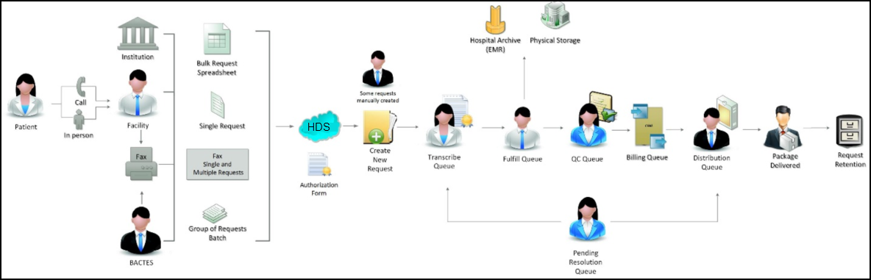
Here’s how it works.

A request begins….

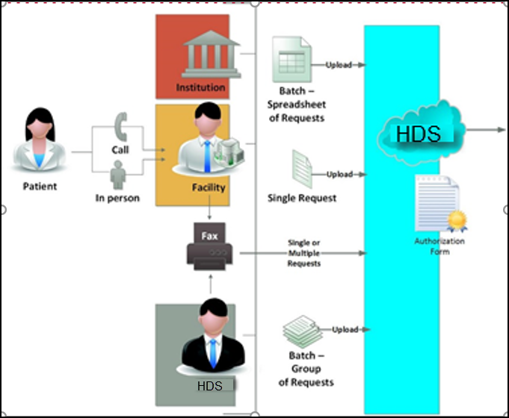

1. Create Request
Requests will come in from HDS requesters that can be clients, patients or HDS employees. Now, you (as client or employee) can quickly start the process right from your desktop.
HDS prompts you to select one or more files from your existing folders. After checking that the list of files is complete, you will upload the files (move the files) into HDS to
- Create a single request, or
- Create multiple requests (from a group of separate documents), or
- Create multiple requests (from a spreadsheet)
You also will upload when adding documents to existing requests.
During the upload step, you can re-assign the Document Type for any selected file, or remove a selected file before creating a request.

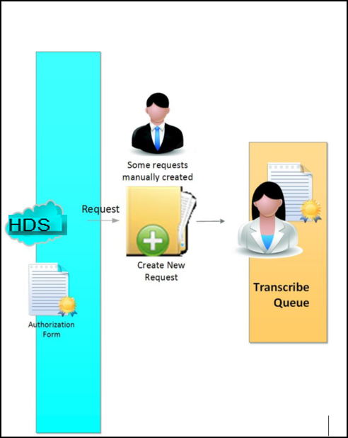

2. Transcribe Queue
Newly created requests automatically move to the Transcribe Queue, where authorized employees key in all needed information – the patient, the client, the requester, etc.
If information is accessible from the system, such as client and requester information in CRM, you can automatically add it to the request without manually typing it in.
When the transcribe task is complete, the request moves to the Fulfill Queue.

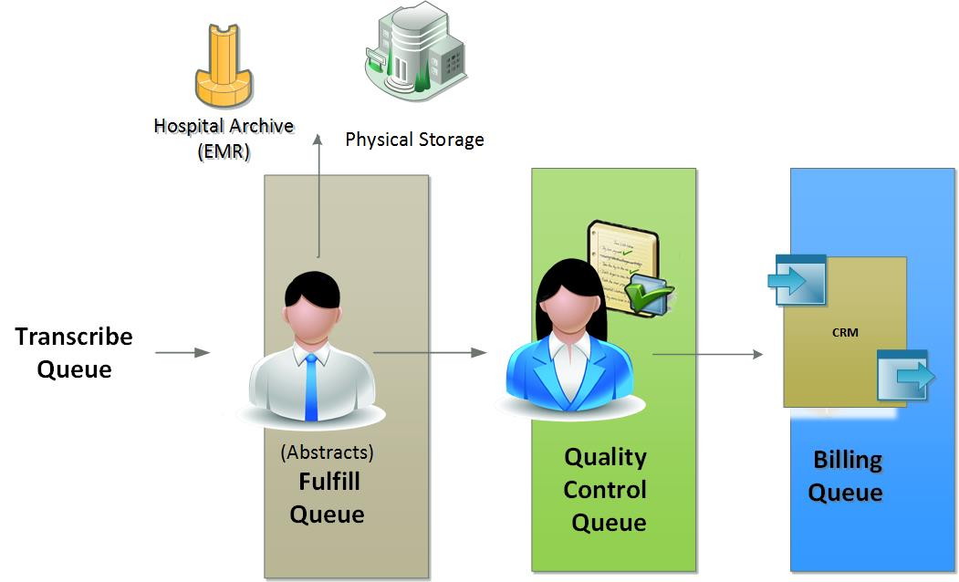
3. Fulfill Queue
From the Fulfill Queue, authorized employees collect the patient records required for the request (Abstracts). After scanning or downloading, these documents are uploaded to HDS. When fulfilled, the request moves to the QC Queue.

4. Quality Control Queue
Here the request is checked online for quality, such as for correct abstracts and the correct recipient. Once the request is complete and quality-checked, it moves to Billing.

5. Billing Queue
The system workflow places the request on hold and checks the billing status against the CRM. If the CRM confirms status and returns an OK to release, the request moves to the next step.

6. Distribution Queue
Standard options:
- Print and mail
- Create a CD and mail
- Send to an FTP site for pick up
Electronic (eDelivery) options:
- OnDemand
- Upload to customer
- Secure email
- Patient Pay Portal

Package delivery follows the specification in the request: “Ship-to” or “Receiver.”

Pending Resolution Queue
Requests move to the Pending Resolution Queue when they require fixing or when, for other reasons, request processing cannot complete.
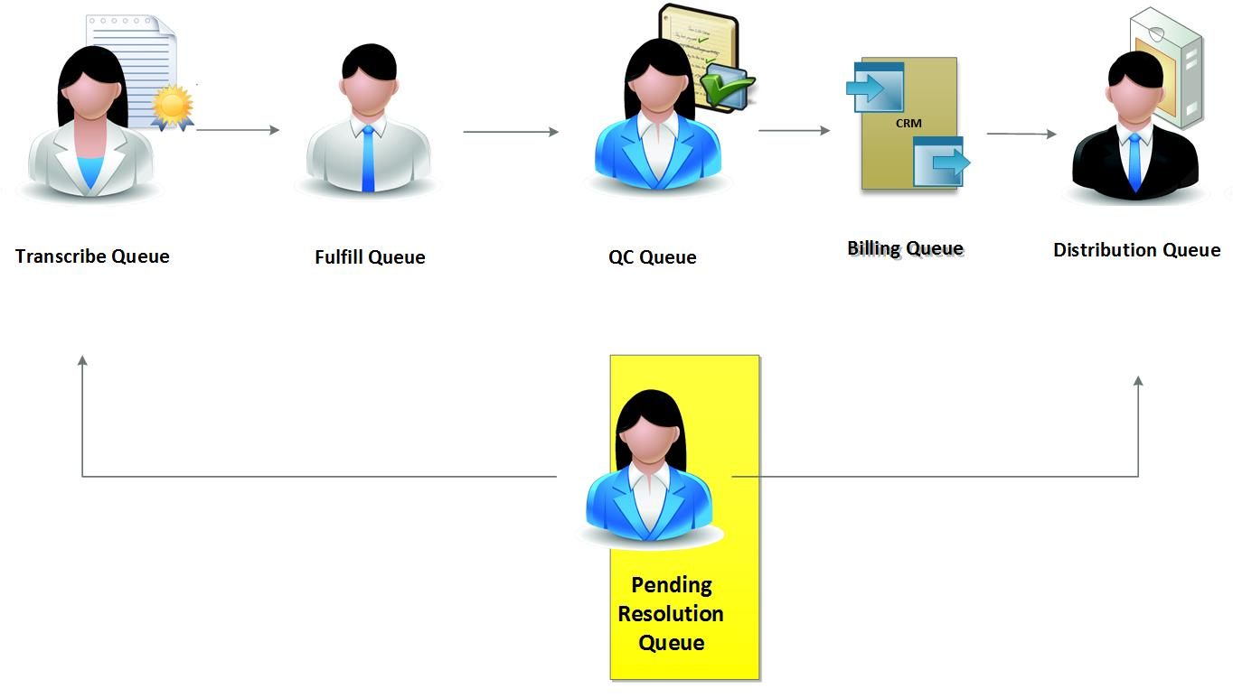
When in the queue, requests can be completed or can be returned to any of the queues for handling.

Retention/ archive policy
Requests and abstracts remain in the system for the time designated by business policy.

Logging In and Out
Follow these instructions for logging in to and out of HDS.
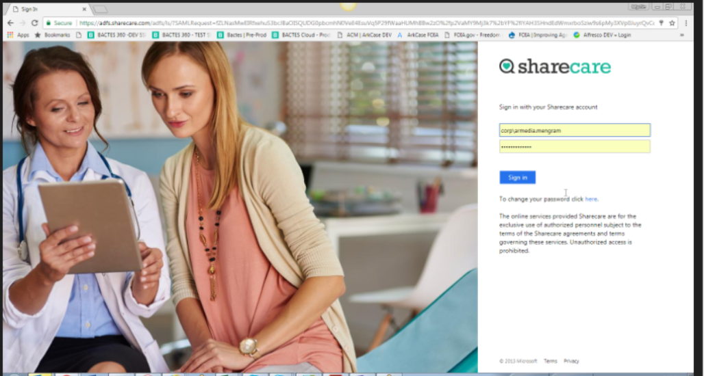

Logging in

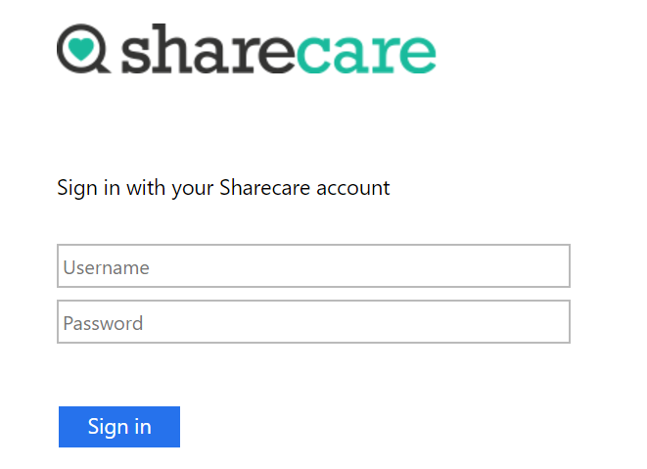
- Enter your username.
- Enter your password.
- Click Sign In.

Logging out
You can log out from anywhere in HDS.
- Click in the Profile frame at the top left in the sidebar. The Profile menu opens.
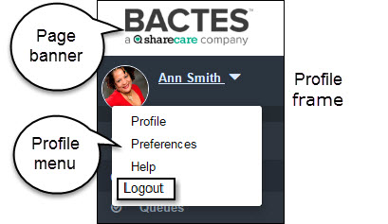
- Click Logout to close HDS.

You will be returned to the Login screen.

HDS Session Timeout
After a designated time of system inactivity (for example, 20 minutes), your online session will expire. The application closes and the message below appears on the login page.
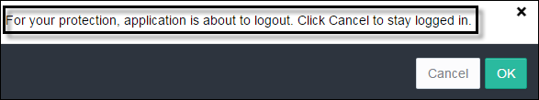

To resume work, click OK.
Important! Don’t unnecessarily lose work to session timeouts. Make regular saves part of your routine. Click the Save (disk) icon as you work.

Getting Around the Health Data System
At center of the HDS system is a group of integrated request queues, each of which has a purpose in the BACTES core business operation.
- Queues are online containers through which requests automatically move–add new requests, track request processing, and complete requests.
- Search, filter, and sort are tools for quickly finding and grouping requests in the system.
- The Dashboard, which is your system landing page, opens first thing every day. It shows a list of all of your requests in progress, and a direct link to each.

Topics in this chapter
The Health Data System Page
The page layout carries throughout HDS.
Health Data System Queues
The list of the request-based modules that comprise HDS.
Finding Content
An introduction to the options for searching HDS content.

The Health Data System Page
HDS makes it easy to find your way around. All pages have a similar look and feel. The topics in this section point out the parts of the page and their use.
The HDS page has three major elements: page banner, sidebar, and content space. The largest element of the page—the content space—displays the content of the selected module.
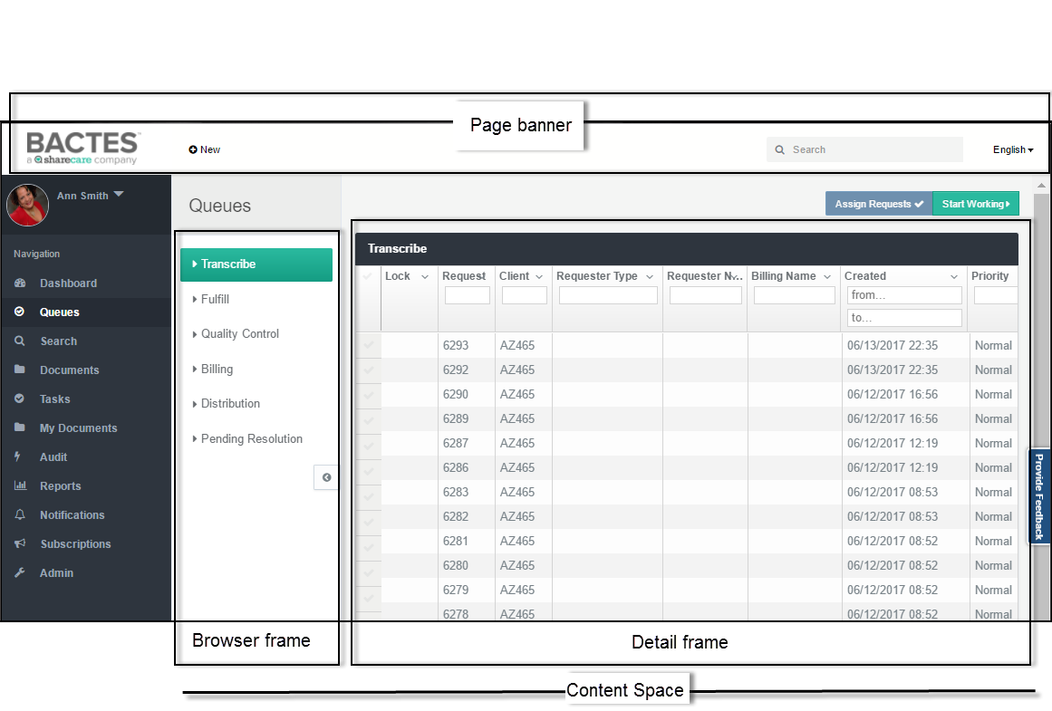
The banner (top) and sidebar (left panel) form the page borders, and appear as standard elements throughout the system.

HDS Page Banner
The banner is the top border of the page (screen). The sections below describe its elements. These links are available from anywhere you are in HDS.
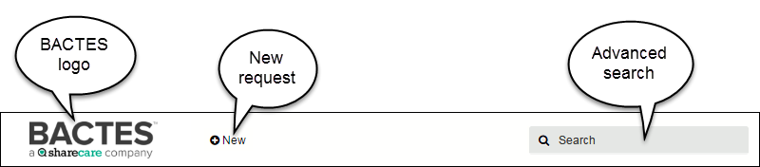

Logo
Click the logo from anywhere in HDS to return to your Dashboard page.

New menu
The New button opens a menu.
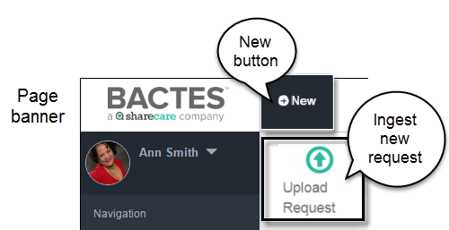
The menu is the initiation point for ingesting (creating) new requests.

Search box
Use the text box to perform global searching of all request-related information in the system. After typing in the search request and clicking Enter, the Search module opens to display the results.
You must have permission to view any search result.
For more information, please go to the Search section in this guide.

Page Sidebar
The sidebar, which forms the left border of the page, is available on every HDS page. The sidebar consists of two frames.
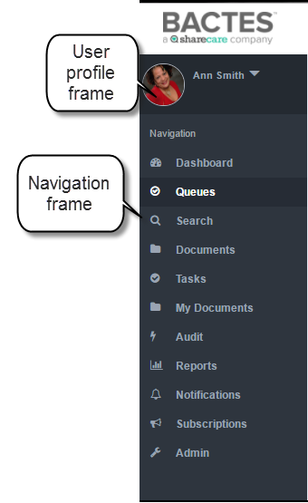

Sidebar frames
User Profile | Identifies you as the logged-in user. The frame makes available a menu of user actions.
Navigation | Shows the list of implemented and future HDS modules. You see only the modules to which you have access.

User Profile Frame
The Profile menu makes available a small set of actions.
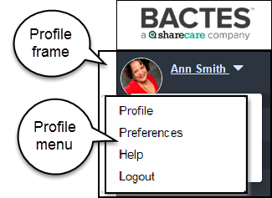

Profile menu options
Profile | Opens your profile page.
Preferences | ---Future Release---  Sets options for displaying content.
Help | Links to the Help pages (HDS User Guide).
Logout | Closes your HDS session.
For more information, please go to the sections Your Profile and Logging In and Out in this guide.

Navigation Frame
Each tab opens a module page.
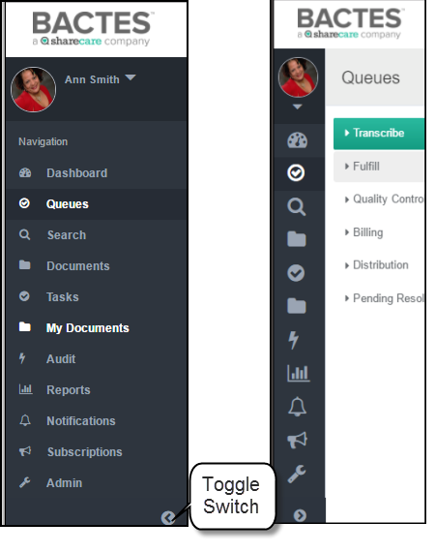
The Toggle button (at the bottom of the Navigation frame) switches between show and hide the module titles on the list. When the titles are hidden, the content space is widened.
The Navigation frame you see may be different than the example above. The list will show only the modules to which you have permission.

Content Space
The content space is the display element of the page. Depending on the module, the space displays:
- Widgets in the dashboard
- Request queue content
- Search results
- Documents
- Tasks
- My Documents
- Audit
- Report results (user role-based access)
- Subscription and notification results
- Audit report (user role-based access)
- Administration tools (user role-based access)
Content displays in two frames: the Browse frame and the Detail frame.
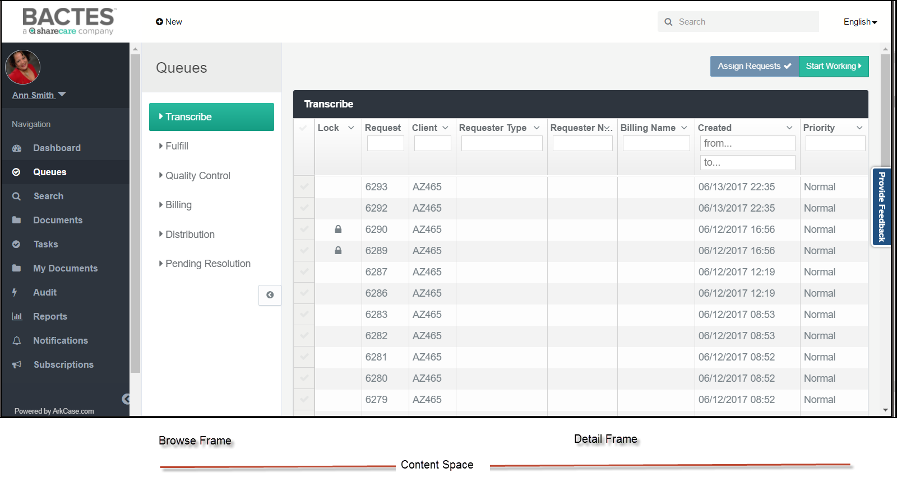
Content frames
Browse | Shows lists or parameters. From here, you can locate and organize module content. Only the modules and queues that you have access to will appear on the page.
Detail | Displays the content of the selected item, for example, content of the selected queue, or the results of searches and reports.
Dashboard page
The Dashboard module is the exception to the standard page layout. There is no Browse frame.
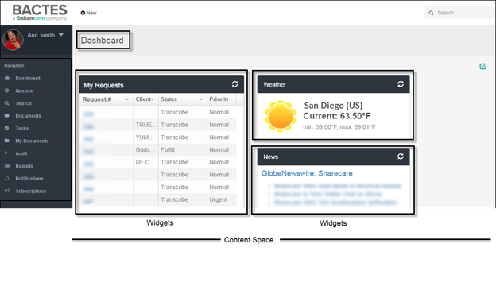
The Dashboard content consists of the widgets you choose to display on the page. For more information about the Dashboard and widgets, please go to the section Your Dashboard in this guide.

Health Data System Modules
HDS is a collection of individual, and integrated, modules (and queues) designed for managing the request process.
The Navigation frame is the list of the HDS modules. Your organization may not use all of them now. Module access is limited by permissions–for example, not all employees can view or modify all requests in progress.
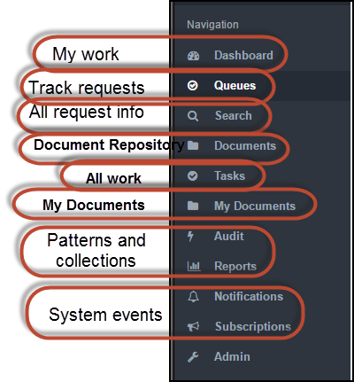
What they do
The modules are integrated. Starting with newly created orders, a business workflow moves requests through the completion phases—from transcribe to distribution.
Process requests | Online action—initiate, fulfill, quality control, billing, distribution, and resolution—automatically updates status and triggers the pre-defined business process that places the request in the (next) appropriate queue.
Trends and behavior | Search and audit read all data stored in the system. Stored data covers request information as well as system actions taken during request completion. The requester can see only the results for which permission exists.

HDS modules
My requests in progress | Dashboard | Your HDS landing page. Here you see the list of requests belonging to you.
Track requests | Queues | Containers store requests by status. HDS moves requests between queues as status changes. Queues make available online tools for initiating, updating, tracking, and closing.
Find information | Search | You define the set of data you want to see by entering full or partial content information. The global search scans the entire repository (historical and in-progress requests): documents/files, request numbers, client and requester names and codes, assignee names, patient names, and full address information.
Store documents | Documents | A location for storing documents in HDS
My work | Tasks | A list of actions assigned to me or my group
Store your Documents | My Documents | A location for storing your documents in HDS
Summarize information | Reports  Audit | Authorized users can create parameters for selecting and running reports of request turnaround time and of request-related actions.
“Follow” requests | Notifications  Subscriptions | --Future Release-- Collection of user-specific event logs created by the system.
Maintenance and configuration | Admin | Restricted to technical and super users. From here, authorized employees can manage behind-the-scenes operations such as application-level security and access control; configuration (of reports, workflow, modules, fields); and request locking.

Your Profile
Your HDS user profile is the space for identifying yourself–by role(s), contact information, location information...even by profile picture.
Here you can see at a glance the organizational groups to which you belong, your title, and your work location. Profile details are particularly helpful when team members work in different locations or for different organizations.
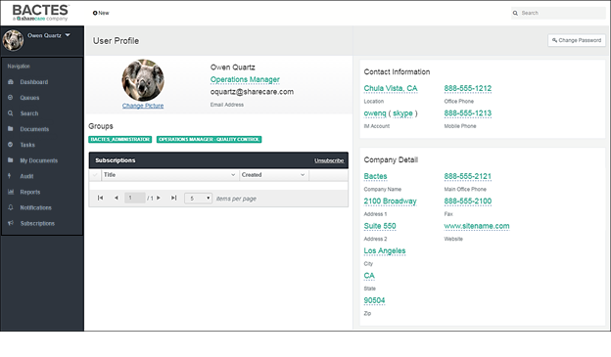
You can view and update your profile from anywhere in HDS.

Topics in this chapter
Opening your Profile
Quickly locate and view your profile.
Updating your Profile
Create and update your profile page.

Opening Your Profile
Only you can open and view your profile–at any time, from anywhere in HDS.
Follow these steps for opening.
- Click the User Profile frame to open the menu.
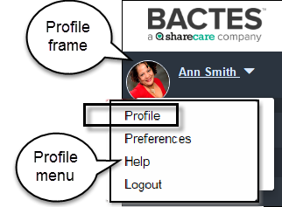
- Click the Profile option from the list.
The first time you open your Profile page, the page will look similar to the example below.
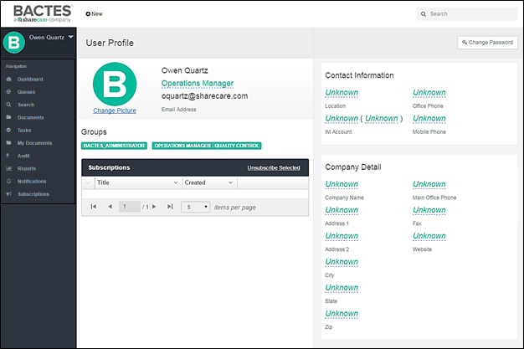
The Profile pre-fills your name and e-mail address. You will add the missing (Unknown) information.

Updating Your Profile
You can return to your profile page at any time to update professional details as changes occur. For example, you can change your title or role, your contact information, and your picture.
- Click the Profile frame to open the pop-up menu.
- Select Profile from the list of options. Your Profile page opens.

Profile Content
You have access to most fields on the Profile page.
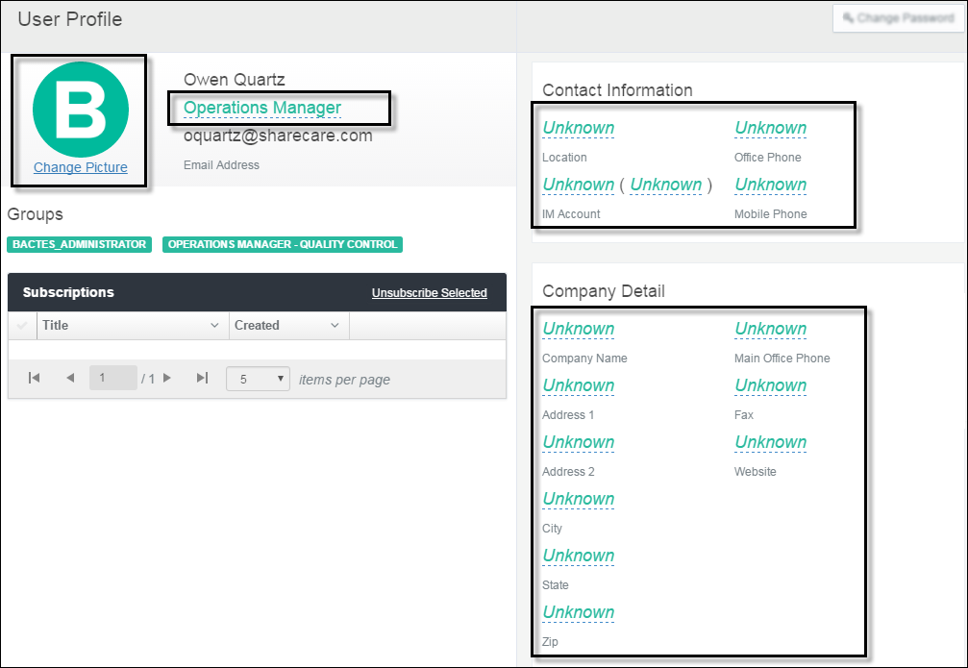
Navigate the page to add and update your profile. All fields on the Profile page are hypertext links marked by dashed underline.
- Click the Unknown hypertext to open a pop-up text box. The first time you open the link the box will be empty.
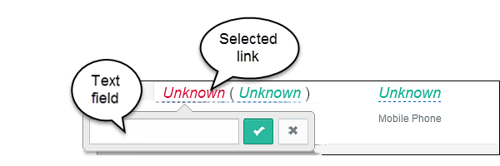
All of the underlined fields can be updated. The pre-filled Unknown indicates no existing information.
- Type in the detail that you want to appear in the fields of your profile.
To change an existing entry, click the link to open the text box.
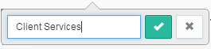
Remove/replace the existing text.
- To save your entry, click the  Save (check mark) button. The new detail appears in your profile.
- To close the text box without saving, click the 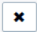 Close (X box) button.
You can change profile details at any time by clicking the current content and updating the information in the pop-up box.
- Continue through every field that you want to add or change.

Your Picture
Follow these steps to add or change your picture.
- Click the Change Picture link. Windows Explorer opens your shared drives and folders.
- Locate and select the image you want to upload.
- When the file name appears in the File name field, click Open. The image is added to your profile.
Acceptable image file formats are .jpeg/jpg, .png, and .gif.

Groups
The user/security group(s) to which you belong appears in the Groups section of the page. System Administration creates and maintains permissions.

Change Password
Not Applicable. There are no separate credentials required for HDS login.

Close the Profile Page
When the information is complete, click one of the modules in the Navigation frame or log out of HDS.

Your Dashboard
The Dashboard is your HDS landing page—it's the first page that opens when you log in. The Dashboard shows your work status in one place. Status information is consolidated in widgets.
Widgets show you a list of items in progress—active requests assigned to you. The widgets also give you quick access to each individual request. From the My Requests widget, you can click a link to open the item.
Because it’s your page, you can configure the Dashboard however you like—you're the only person that sees it.
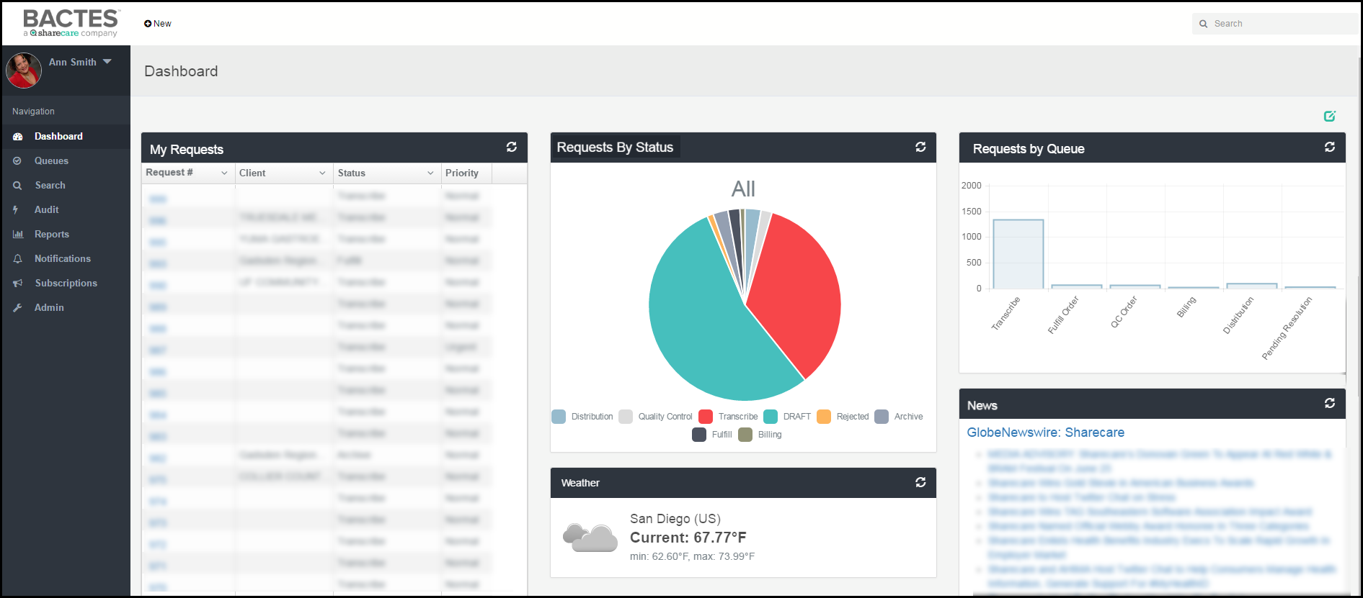
Your role(s) and permissions determine the widgets and the content that you see.

Topics in this chapter
Dashboard Edit Mode
First step in customizing your Dashboard.
Personalizing the Widgets
Working with the elements of the Dashboard.
Personalizing the Space
A tour of the Dashboard page layout options.

Dashboard Edit Mode
Actions to the page require that the Dashboard be in edit mode. Edit Mode makes available the options for editing components of the page. By default, the Dashboard is not in edit mode. Switch to edit to begin. Edit Mode enables the options to:
- Add widgets to your dashboard (permissions determine the widgets available)
- Modify widget display (change content, move position, remove from view)
- Configure the layout of your dashboard (names of widgets and the number displayed in each row)
The first step to personalizing your Dashboard is edit. To make available editing options, click the Edit Mode (pencil icon) button in the right corner of the Dashboard title bar.
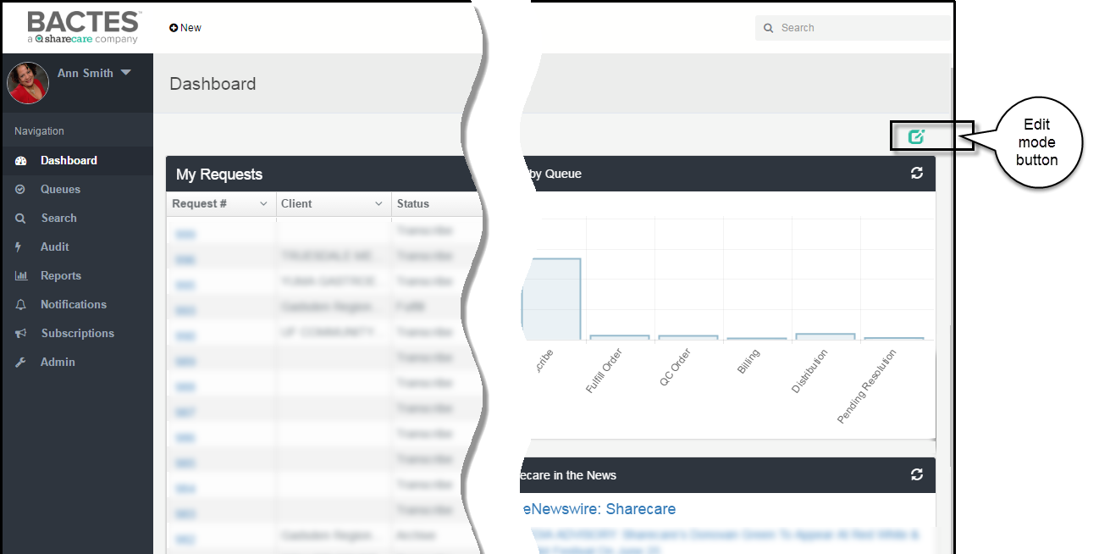

Dashboard Edit Actions
When edit mode is enabled, a set of edit buttons becomes available in the Dashboard title bar.
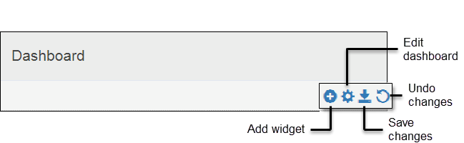
Dashboard edit mode buttons
Add Widget | Opens the list of widgets, you select the ones that you want to see on your dashboard.
Edit Dashboard | Opens the options for reconfiguring the widget display on the dashboard.
Save Changes | Saves the changes made to the dashboard, closes Edit mode.
Undo Changes | Restores original settings, closes Edit mode.

Widget Configuration Buttons
After enabling the Dashboard edit mode, widget configuration buttons automatically appear in the widget title bar.
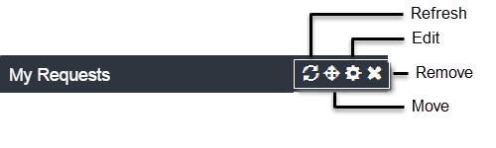
Widget configuration buttons
Refresh | Updates (reloads) content with the latest available information: updated requests; latest request status; news and weather.
Move | Permits dragging of the widget to a new location on the dashboard.
Edit | Opens a text box for changing the title of the widget; the time for collecting data; and the outside source of non-business content.
Remove | Hides the widget from display on the dashboard.

Personalizing Dashboard Widgets
The widgets on the dashboard give you a simple and up-to-date overview of work in progress. You can directly open a request from the list in the widget. After adding widgets to the dashboard, you can configure and move them around in the space.
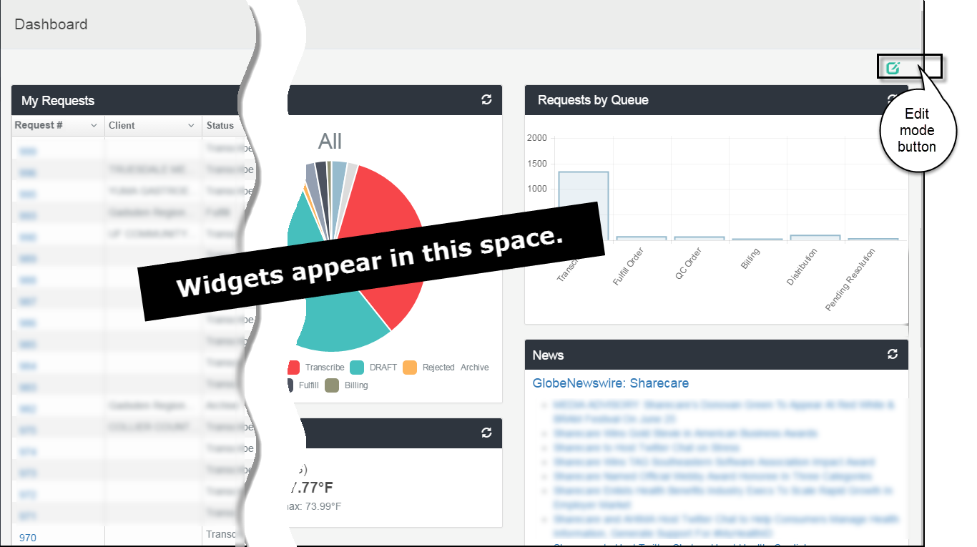

Widget Actions
Add a Widget to Your Dashboard
Edit Widget Configuration
Move a Widget
Remove a Widget

Add a Widget to Your Dashboard
- Widgets showing status
- Widgets showing summary data
- Widgets showing external data
- Widget showing the HDS archive
You choose the widgets that you want to see.
- If the Dashboard page is not in edit mode, click the Edit Mode (pencil icon) button on the Dashboard title bar.
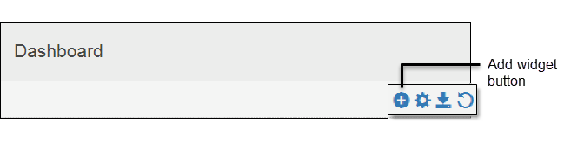
- In Dashboard edit mode, click the Add (plus sign) button on the Dashboard title bar to open the Add New Widget menu.
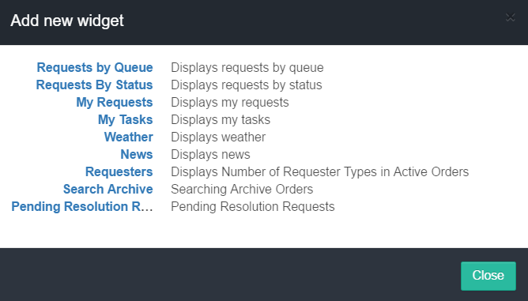
- Click a widget title to select it.
The Add New Widget dialog box will close and the widget will be added to your dashboard.
Names of widgets and number of available widgets may be different than the example.

Widgets showing status
The My Requests widget is a list of those items to which you are assigned and for which the status is incomplete.
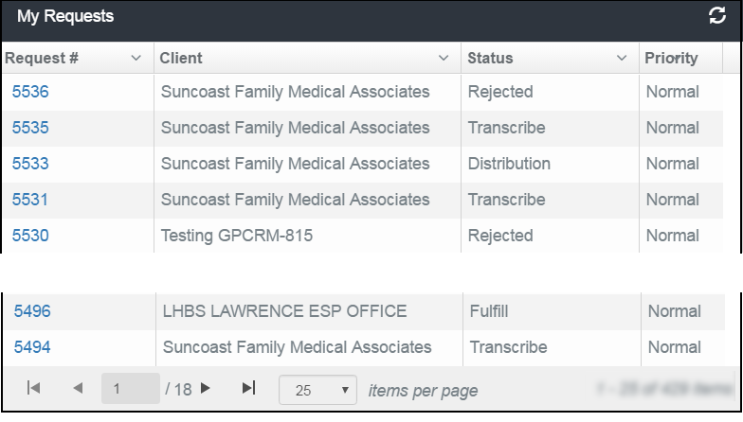
The widget identifies each item by metadata (information) such as number, client, priority, date, and status.
Each item in the Request Number column is a hyper-link, from which you can open the selected request.
The Admin role has permissions to see all existing orders in all queues. Depending on your role, the widget will list only the current orders and the queue assigned to you.

Widgets showing summary data
Widgets such as Requests by Status, Requests by Queue and Requesters display cumulative content as a pie chart or graph. See the pie chart example below.
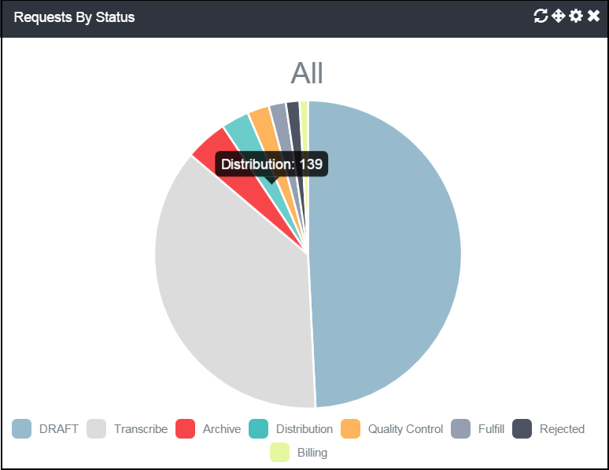
To see the numeric value that a section of the pie chart represents, move your cursor over the chart. A hover box will show the number.
- To specify a period for data collection, click the Configuration (cog) icon (requires Dashboard edit mode).
- To refresh the results with latest information, click the Reload icon.

Widgets showing external data
These widgets show information that originates from external sources. Widgets such as Weather and News are independent of the HDS repository.

Widget showing the HDS archive
The Archived Requests widget is the list of all requests that have been moved to archive.
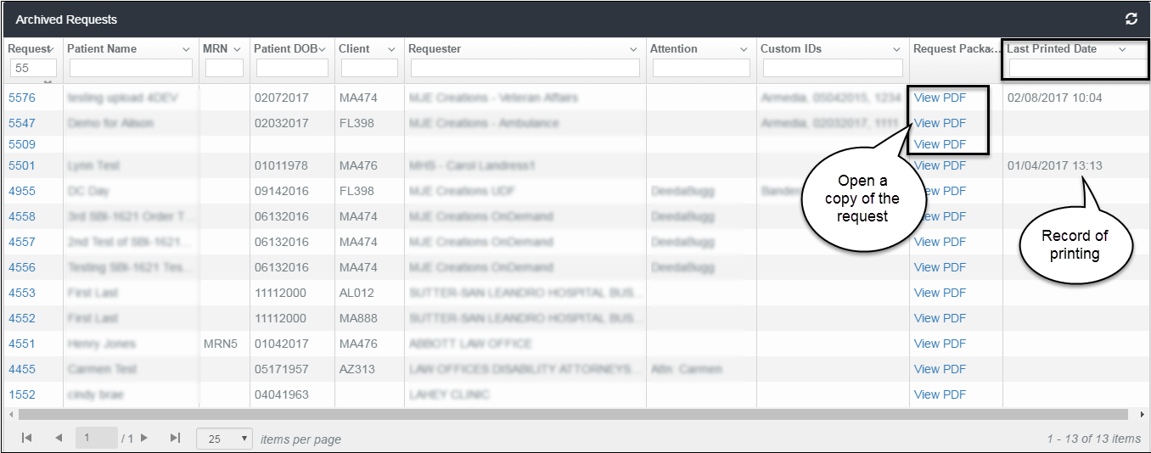
You can filter and sort the list columns as you would any other widget. You can see the content of the request by clicking the View PDF link in the Request Package column. HDS also stores and displays Last Printed Date, which you can use in search and audit criteria.

Edit Widget Configuration
You can modify basic elements of the widget display–change its title or the number of items that display on a page. Options available depend on the widget content and access permissions.
- If the dashboard page is not in edit mode, click the Edit Mode button on the Dashboard title bar. The control buttons become available on the widget title bar.
- Click the Edit Widget Configuration button on the widget title bar.
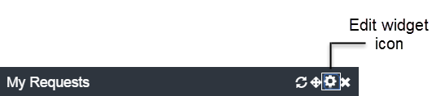
The edit widget dialog box opens.

My Requests widget

Requests by Queue widget
You can change the name that appears on the title bar of the widget.
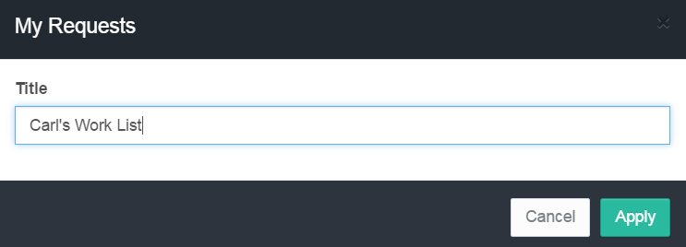
- Click in the Title text field and edit the current content.
- Click Apply to save the change and close the dialog box.

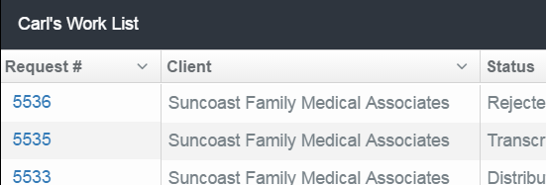

Requests by Status widget
You can change the title of the widget and the default time period for which to collect data.
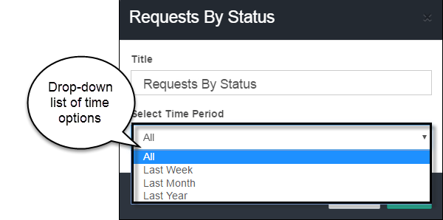
- Click in the Title text field and edit the current content.
- Open the drop-down list in the Select Time Period field. The default setting is All, that is, no time limit. Options for narrowing the comparison are previous Week, Month, and Year.
- Click Apply to save the change and close the dialog box.

Externally linked widgets
Two widgets provide Weather and News information.
Both configurations allow changes to the widget title, in the same manner as all the other HDS widgets. To activate widget content:
Widget
Weather | To see basic weather information, enter a city, state, and country abbreviation (U.S.).
News Feed | Enter the URL of the news source.

Move a Widget
You can move a widget from one location on the Dashboard to another.
- If the dashboard page is not in edit mode, click the Edit Mode (pencil icon) button on the Dashboard title bar. The control buttons become available on the widget title bar.
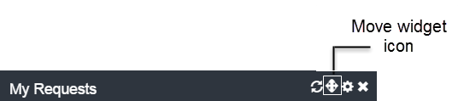
- Click and hold the Change Widget Location (cross) icon and drag the widget to the new spot in the Dashboard content frame.

Remove a Widget
You can remove a widget from your dashboard. The action hides the widget from view, it does not delete the widget from the system.
- If the dashboard page is not in edit mode, click the Edit Mode button on the Dashboard title bar. The control buttons become available on the widget title bar.
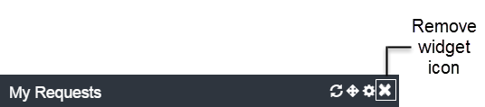
- Click the Remove Widget (X) icon to hide the widget from display. The widget will not appear again until you add it.

Widget Content
You have several options for viewing widget content.
- Sort the List
- Hide Content
- Adjust Column Width
- Change List Scrolling Options
- Navigate the List Pages
- Refresh Widget Content
- Link to Requests

Sort the List of Requests
Arrange and locate content using Sort. Sort is available in each data column of the My Requests widget.
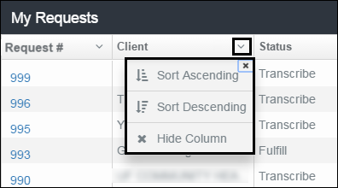
- To re-order the list, click the Disclosure (down arrow) button in the column heading to open the selection box.
- Select the request—ascending or descending—for re-displaying the list content.

Hide a List Column
- Click the Disclosure (down arrow) button in the column heading to open the selection box.
- To show the list without the column, click Hide Column.
- To restore the column to view, click the widget Reload icon.

Adjust column width
You can widen (or narrow) the size of any column in the results list.
- In the header row at the top of the list, place the cursor on the column border. The cursor will change to a double line.
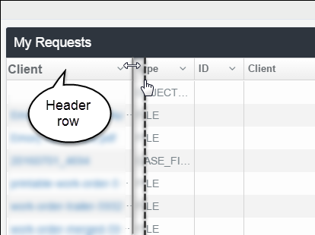
- Drag the line to the right or left to adjust the width.

Change the List Size Display
The default number of items showing on each page of the Requests widget list is 25. To view item 26, you must navigate to the next page.
- To increase (or decrease) the number of requests you want to see on each screen (page), scroll to the bottom of the widget list.
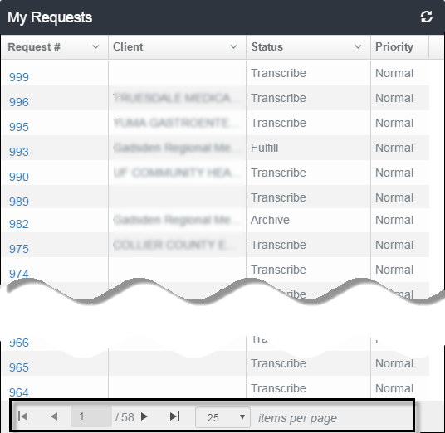
- Next to the items per page label, click the Disclosure (down arrow) button in the column heading to open the selection list.
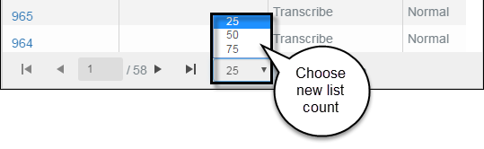
The default display setting for the Requests list is 25 items per page. You can change the count to 50 or 75.
- Click to select a new count. The selection dropdown closes and the list length adjusts to the new size.
You can change the list item size at any time. It is not necessary to enable the dashboard edit mode.

Navigate the List Pages
To move between pages in the widget, use to GoTo arrows at the bottom of the list.
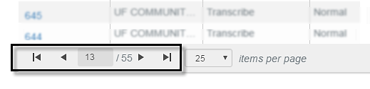
- Page forward: Click to open the next page, or | to go to the last page of the list.
- Page backwards: Click to open the previous page, or | or to return to the first page of the list.

Refresh Widget Content
Use the Reload (refresh) action to update content with the latest information.

Click the Reload button. The widget content will automatically refresh the latest information.
You can reload widget content at any time. It is not necessary to enable the dashboard edit mode.

Link to Your Requests
Each Request number on the widget list is a hyperlink.
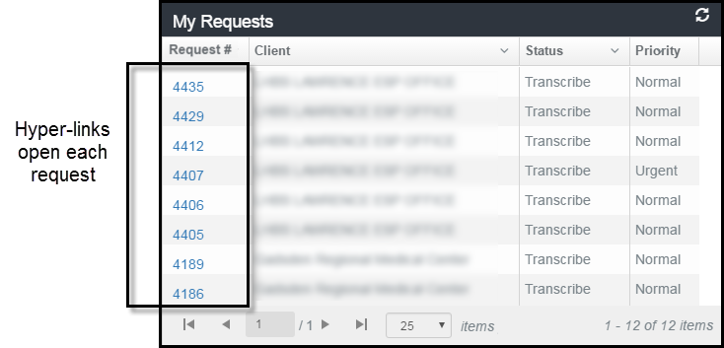
Click the link to open a request. Only the request number in the My Requests widget is an active link.

Personalizing the Dashboard Page
You can personalize your dashboard page by changing the title of the page and by changing the display structure of the content frame.
The Dashboard page has three major components: the title bar, the Edit mode button, and the content space which displays the widgets you choose to see.
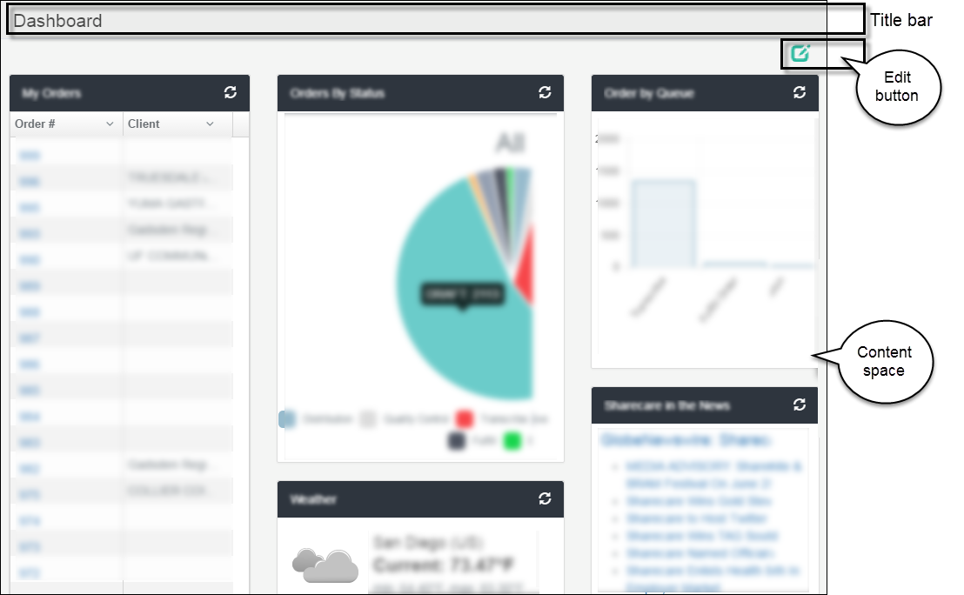

Change the Title of the Dashboard Page
The default title of the page is "Dashboard." You can personalize it to read whatever you want, for example, "Bill's Dashboard."
- If the dashboard page is not in edit mode, click the Edit Mode button on the Dashboard title bar.
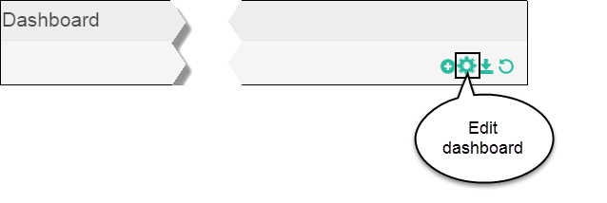
- Click the Edit Dashboard (cog) button on the Dashboard title bar. The Edit Dashboard modal window opens.
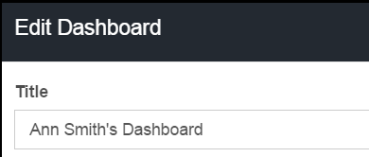

- Click in the Title text field and edit the current content.
- Click Close to save the change and close the modal window.

Change the Dashboard Page Layout
You can change the structure of the dashboard display—how the widgets line up in the content space.
The layout example below shows the widgets arranged in three columns.
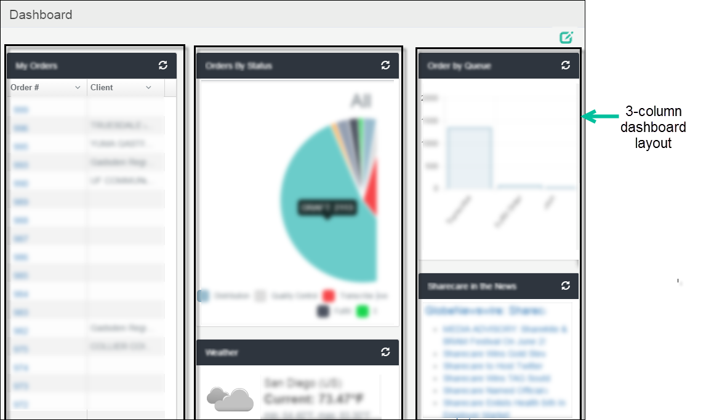
The column widths are adjustable, which affect the presentation of the widget content. There are several options available for rearranging the widgets in the content frame.
- If the dashboard page is not in edit mode, click the Edit Mode button on the Dashboard title bar.
- Click the Edit Dashboard (cog) button on the Dashboard title bar. The Edit Dashboard modal window opens.
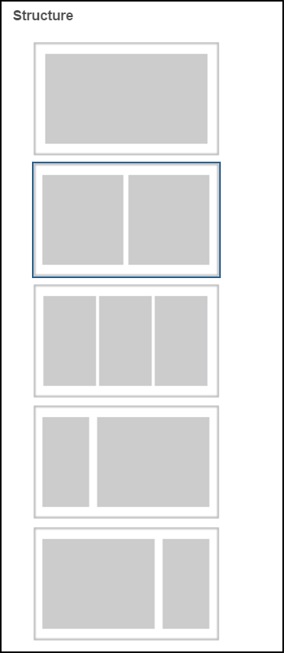
- Click to select the structure, or layout, in which to see the widgets in your dashboard.
- Click the Close button.
- To save the new widget arrangement, click the Save icon.

Create Requests by Upload
HDS streamlines the Create Request process. You can create a new request simply by uploading files online from your computer—a single file, a group of documents, a spreadsheet of requests—to HDS.
The screen below is an example of the Upload Requests page.
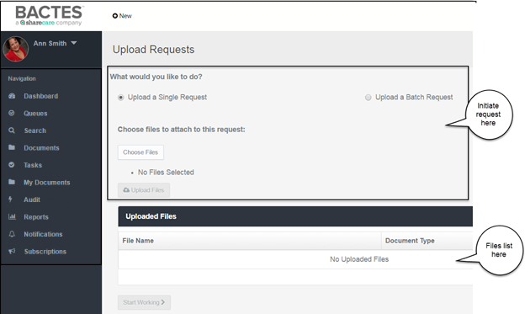

Topics in this chapter
Upload Single Request
When selected, you have the option to create a request containing one or more files.
Upload a Batch Request of multiple documents
You can upload two or more individual requests.
Upload a Batch Request from a spreadsheet
HDS will create any number of requests from a spreadsheet.

Single Request
This section describes the steps for uploading a single request.
Quick Steps

- Choose file(s) | Click Choose Files to select files from your shared drives and folders.
- Upload the file(s) | Click Upload Files to review the selected files in the Uploaded Files list.
- Change Document Type(s) | If necessary, change the document type(s) in the request.
- “Start Working” | Click Start Working to review and update the request.
- Change Client Information | If the default client needs changing, search for the name to complete the section.
- Add Patient Information | If New Patient, add the required information to the request.
- “Create Request” | Click the button to create the request number and automatically place the request in the Transcribe queue.

Upload a request
Start the request from the New menu on the page banner.
- Click the + New icon to open the pop-up menu.
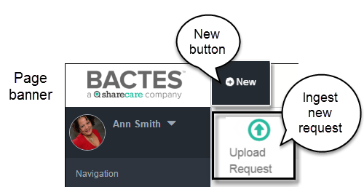
- Click the Upload Request icon to open the request page.
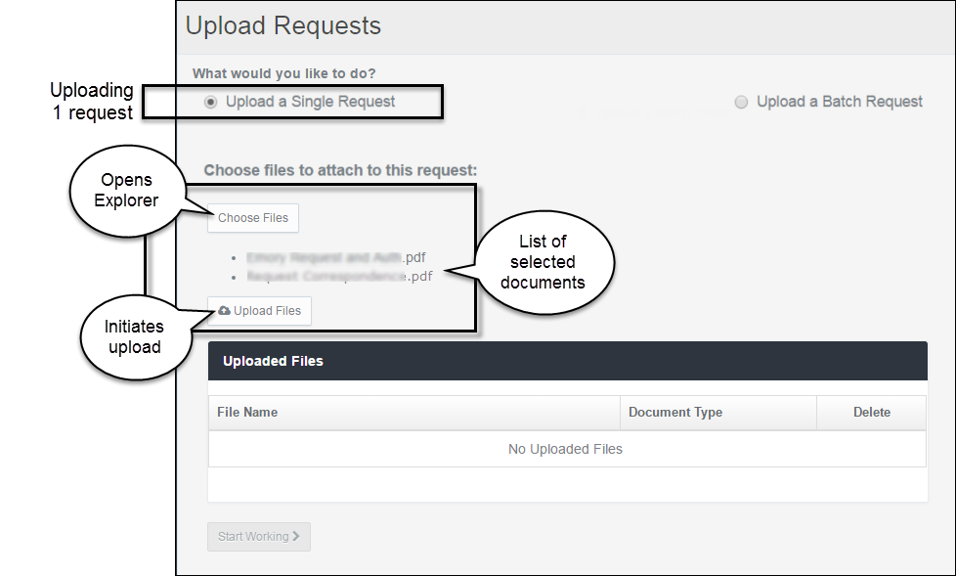
A single request can contain several documents.
Single Request buttons
Upload a Single Request | In the section of the page titled What would you like to do?, select Upload a Single Request.
Choose Files | Click Choose Files to open Windows Explorer on your computer.
 | From a folder, select the file(s) for upload and click Open.
File Types
All documents in the request package must be .pdf files. You can upload other file types (such as Microsoft Office or graphics) and HDS will convert them to .pdf.
 | The Explorer window closes and the name of the selected file(s) appears in a bulleted list below the Choose Files button.

To delete the entire selection of files before upload, click the Choose Files button. The Windows Explorer screen opens and the previously selected items are removed. You can reselect files or Cancel to discontinue the request.

Upload Files | Click the button to move the file to the Uploaded Files list.

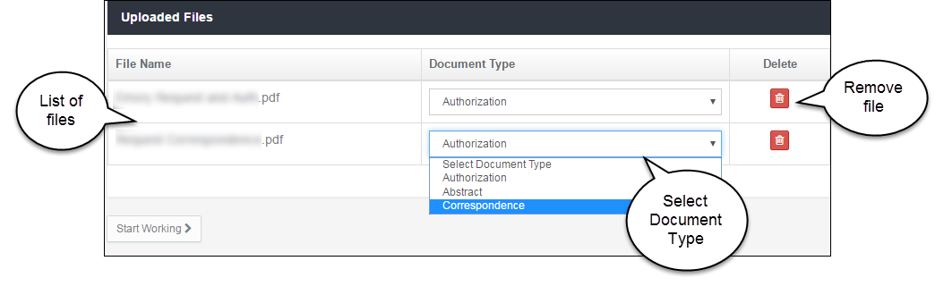
In the example, the request contains an Authorization document and a piece of correspondence. The Document Type default is Authorization.
- To change the Document Type, open the drop-down list and select another type.
- To remove a file from the request, click the red Delete (trash can) icon.
- When the documents are complete, click the button. The Single Request page opens.

Create the Request
The screen below shows the first page of the first document in the request, thumbnails of all pages in the document, and the detail tabs for completing request information. By default, the Details tab is open.
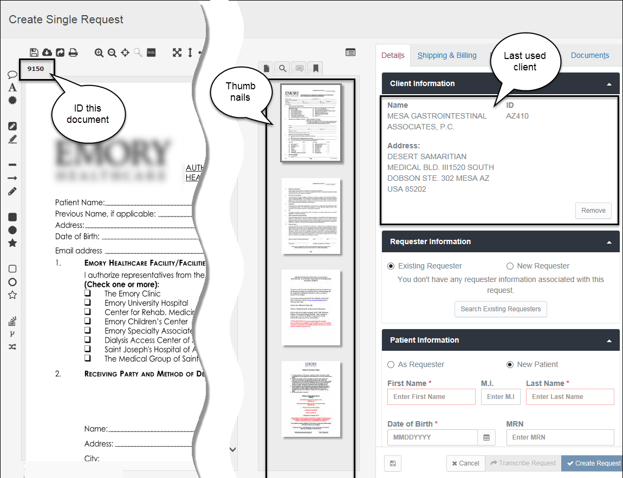

Single Request page
Document identifier |  | The system assigns a unique identifier to each document uploaded. The document number appears in a tab above the document display section of the Request page. The example represents a request containing one document.
Thumbnails frame |  | All pages of the selected document appear in the narrow thumbnails frame in the center of the page. Click a thumbnail to move through the document and to view the page in the document display space. A toggle above the thumbnails hides the frame from view.
Document details |  | The Details tab of the Details frame automatically opens in the Request page. The tab contains information required to create a request.
Required Details | When creating a single request, two pieces of information are required: Client and Patient.
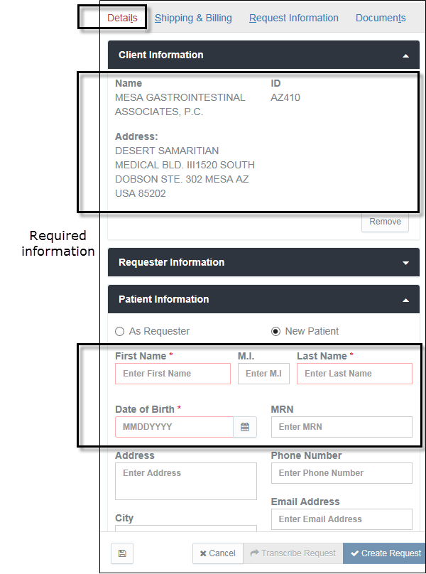
The Create Request button is dimmed (not available) until you add the required information. Sections and fields marked with red indicate the minimum information required to create a request.

Do you want to change the Client?
When creating a new request, the system pre-fills the Client Information section with the name of the last client you associated with a request.
The system makes available two sources of client information if a change is needed: a list of recently used clients and search of all clients that you have permissions to use.
- Click the Remove button to change clients.
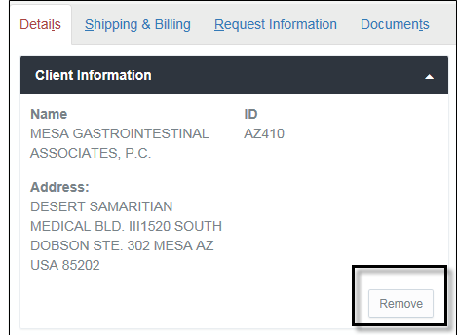
- Select an option for locating the replacement.
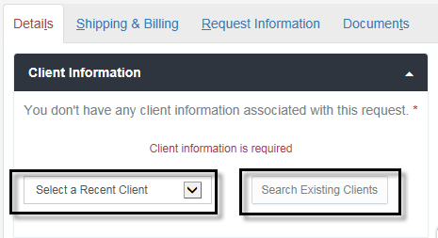
Clients recently used | Click the field Select a Recent Client to open a list of clients you commonly use and highlight the name you want.

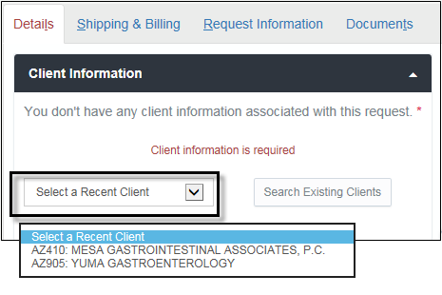
The system collects any number of clients you have used in previous requests. The listing is a function of your browser (for example, Microsoft Internet Explorer (IE) or Google Chrome). If you switch browsers, the system will begin creating a new list.

Clients not on the Recent list | Click the field Search Existing Clients to open the search box. See the steps below.

If you are an Administrator
You may have access to all clients. The search box opens.
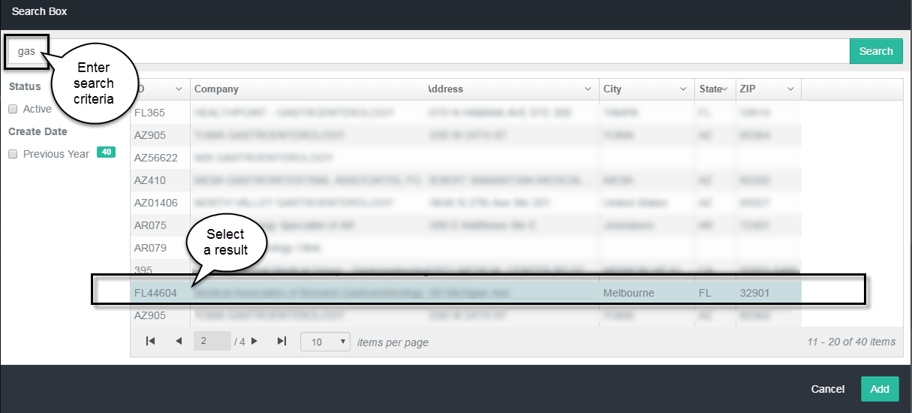
- Type at least three characters in the text box and click Search.
HDS applies global searching. When the request contains partial information, the search will return all instances found in identification codes, company names, point of contact names, street addresses, cities, states, and zip codes.
Search facets | When multiple records return, a set of filters (facets) is available to further narrow the results. Facets are common characteristics found within the set of results that can be used to group items on the list. The facets appear in the left column of the results screen.
Sort the list of results | To re-order (sort) the list of results, click the Disclosure (down arrow) button in a column heading and select ascending or descending from the drop-down list.

- From the search results list, click to select the client and click Add. The client information is associated to the request and the search screen closes.

If you are not an Administrator
You may have access to a specific group of clients. The list of your authorized clients appears after clicking Search Existing Clients.
- Click a name to associate the client to the request.
The new client will appear in the Client Information section.

Add Patient Information
- Enter at least the minimum patient information: First Name, Last Name, and Date of Birth.
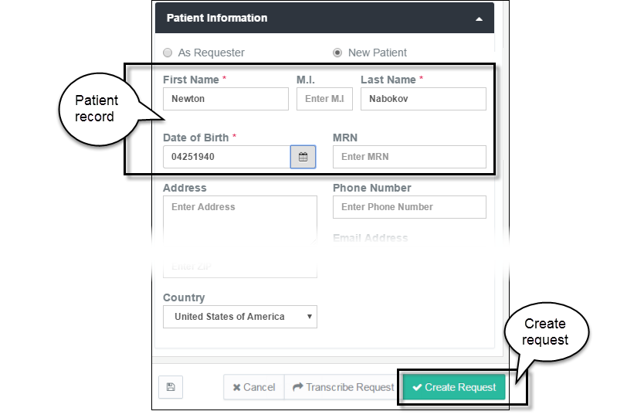
- Click Create Request. The request moves to the Transcribe Queue. The queue opens, showing the new request and the request number.
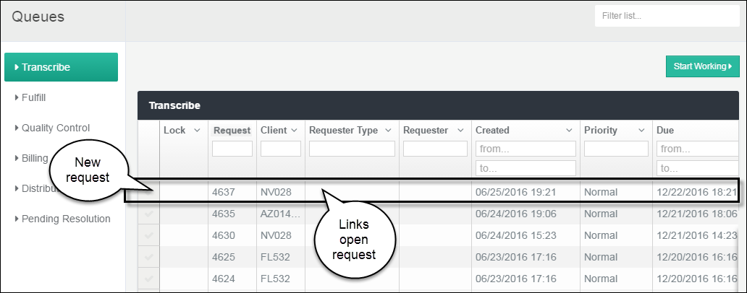
To return to the request page, click any column in the row of request details. Every column is a hyper-link that opens the respective request page. You can continue to add or to revise requests until complete.

Batch – Group of Requests
This section describes the steps for uploading a batch of two or more individual requests.
Quick Steps

- Choose file(s) | Click Choose Files to select files from your shared drives and folders.
- Upload the files | Click Upload Files to review the selected files in the Uploaded Files list.
- Change Document Type(s) | If necessary, change the document type(s) in the request.
- Edit Batch | Click Edit Batch to review and update the request.
- Change Client Information | If the default client needs changing, search for the name to complete the section. The Client automatically applies to every request in the batch.
- “Create Request” | Click the button to create requests numbers and automatically place all requests in the Transcribe queue.

Upload a Group of Documents
Start the request from the + New menu on the page banner.
- Click the New icon to open the pop-up menu. `
- Click the Upload Request icon to open the request page.
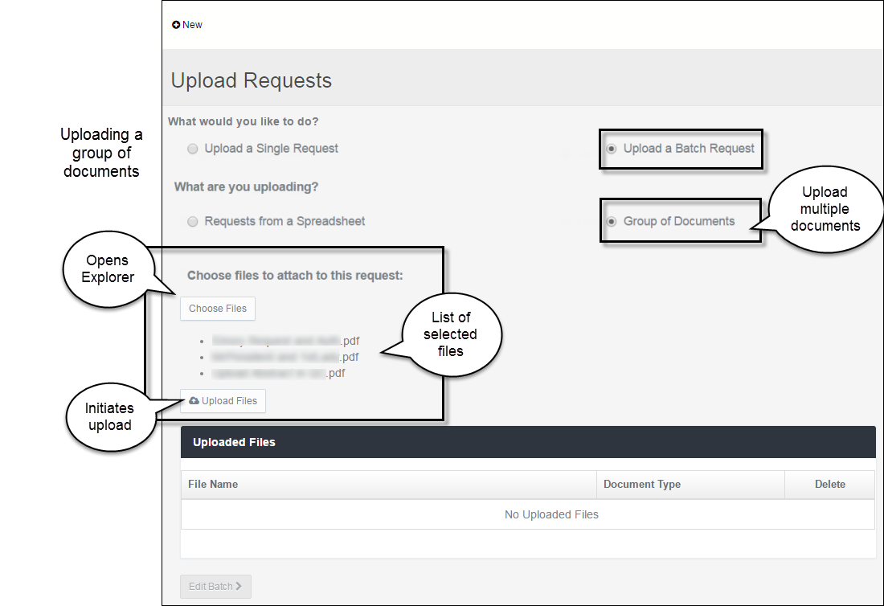
Group Request buttons
Upload a Batch Request | In the section of the page titled What would you like to do?, select Upload a Batch Request (to send several requests).
Group of Documents | In the section of the page titled What are you uploading?, select Group of Documents.
Choose Files | Click Choose Files to open Windows Explorer on your computer.
 | From a folder, select multiple files for upload and click Open.
File Types
All documents in the request package must be .pdf files. You can upload other file types (such as Microsoft Office or graphics) and HDS will convert them to .pdf.
 | The Explorer window closes and the names of the selected files appear in a bulleted list below the Choose Files button.
Create the upload | After verifying the files selected from your folder, click Upload Files. The file names reappear on the Uploaded Files list.

To delete the entire selection of files before upload, click the Choose Files button. The Windows Explorer screen opens and the previously selected items are removed. You can reselect files or Cancel to discontinue the request.

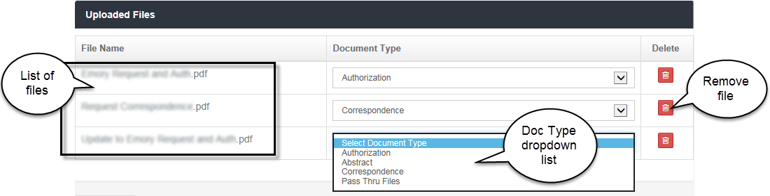

Document Type | The Document Type default is Authorization. To change a Document Type, open the drop-down list and select another type.
Do you want to remove a file from the batch?
Click the Delete (trash can) icon corresponding to the file.
- When the list of batch requests is correct, click the button. The Create Batch Requests page opens.

Create the Requests
When the batch successfully uploads, the Create Batch Requests page opens. You’re now ready to create the individual requests in HDS.
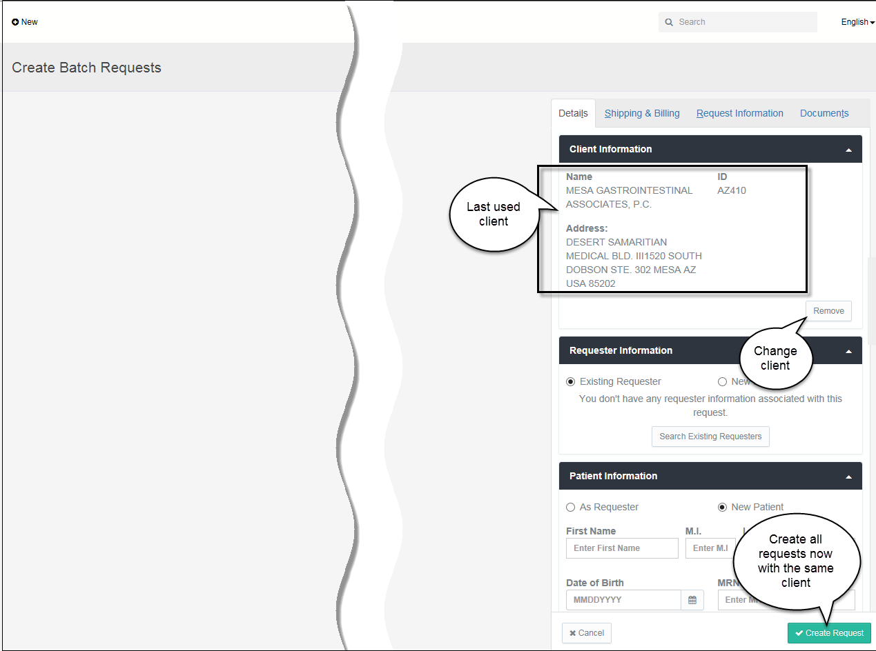

Do you want to change the client?
When creating a new request, the system pre-fills the Client Information section with the name of the client most recently used. The client is associated to every request in the batch. If necessary, you can associate a different client to all the requests.
- Click the Remove button to change clients.
- Select an option for locating the replacement.
Clients recently used | Click the field Select a Recent Client to open a list of clients you commonly use and highlight the name you want.
The system collects any number of clients you have used in previous requests. The listing is a function of your browser (for example, Microsoft Internet Explorer (IE) or Google Chrome). If you switch browsers, system will begin creating a new list.
Clients not on the Recent list | Click the field Search Existing Clients to open the search box.

If you are an Administrator
You may have access to all clients. The search box opens.
- Type at least three characters in the text box and click Search.
HDS applies global searching. When the request contains partial information, the search will return all instances it finds in identification codes, company names, point of contact names, street addresses, cities, states, and zip codes.
Search facets | When multiple records return, a set of filters (facets) is available to further narrow the results. Facets represent common characteristics found within the set of results that can be used to group items on the list. The facets appear in the left column of the results screen.
Sort the list of results | To re-order (sort) the list of results, click the Disclosure (down arrow) button in a column heading and select ascending or descending from the drop-down list.

- From the search results list, select the client and click Add. The client information is associated to this request and the search screen closes.

If you are not an Administrator
You may have access to a specific group of clients. The list of your clients appears after clicking Search Existing Clients.
- Click to select a different client to associate to this request.

Create Request button
To automatically create all the requests and move them to the Transcribe queue, click Create Request. (Jump to the section titled Create Requests below if you do not need to review the files or change document type.)
To see the list of files in the batch before moving to the Transcribe queue, change a file’s Document Type, or to view the contents of a file, open the Documents tab.

View the list of requests Individual
- Click the Documents tab to view the list of requests.
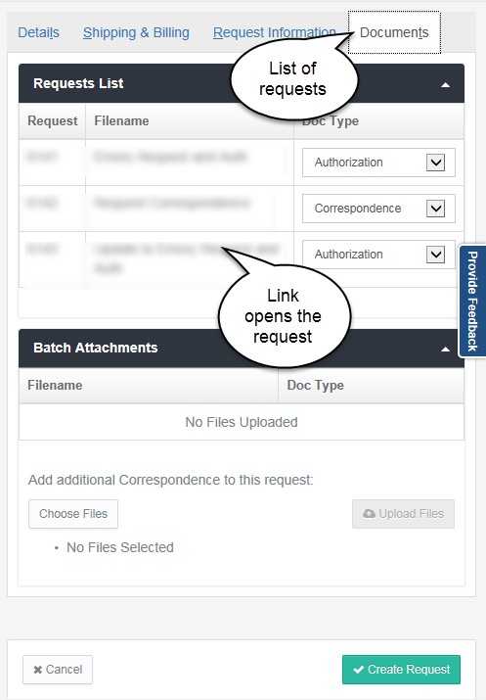
List of requests | The Documents tab (in the detail frame on the right side of the page) shows the list of all the files in the batch.  While the requests may not yet be complete and formally created, the system assigns Request numbers to each document.  The Filename does not change; the system retains the name of the file uploaded from your local Explorer list.  From the Documents tab, you can also reassign Document Type, if necessary.
Order of the documents: The files are organized in the order they appear in your Windows Explorer list. HDS assigns consecutive Request numbers beginning with the first file on the list.
 If you want the requests to appear in another order, organize the filenames in Explorer before upload.
- To change a document type, click in the Doc Type field and select a different type from the dropdown list.
- To open the request, click a filename. The pages of the file appear in the content frame of the page.
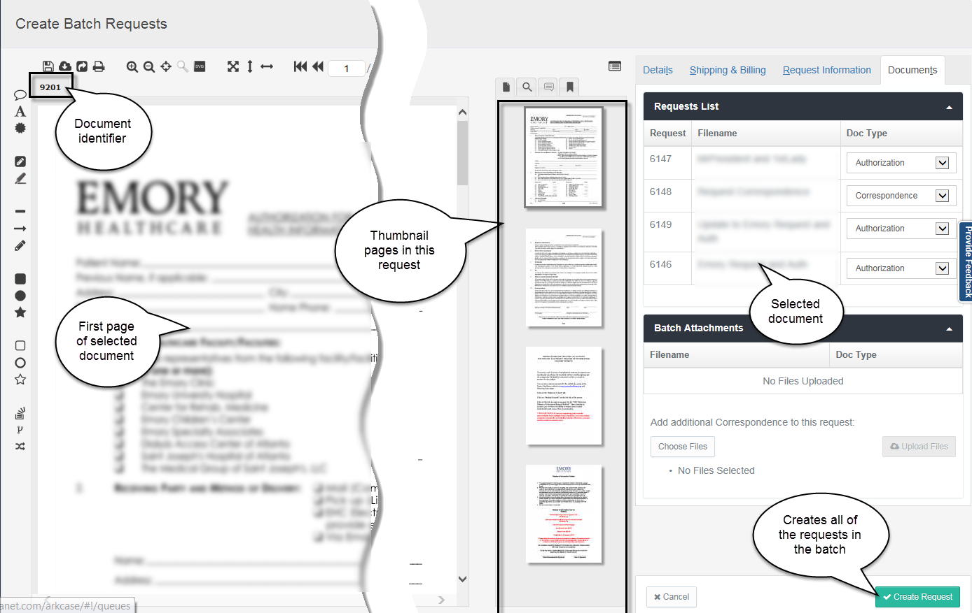
The screen shows the first page of the selected request, thumbnails of all pages in the request, and the tabs for updating the request details.
On the Create Batch Requests page
Document identifier | The system assigns a unique identifier to each document uploaded. The document number appears in a tab above the document display section of the page.  When you return to the request page, these tabs show at a glance the number of documents in the package. Click a tab to quickly open one of the documents.
What do these identifiers tell you?
There is only one Authorization document and one Abstract document in a package. (The document title is the file name of the first document of the document type uploaded.) When subsequent files of these document types are added to the request, the pages of the uploaded files append the existing file—add pages to the total count.
Every piece of Correspondence, which is not counted in the package page total, is stored as a separate document. A unique identifier tab is created for every correspondence document added to the request.
Content frame | A full view of the first page of the selected request appears in the left frame of the screen.

Thumbnails frame | All pages of the selected document appear in the narrow thumbnails frame in the center of the page. Click the thumbnails to move through the document and to view the page in the document display space. A toggle above the thumbnails hides the frame from view.
Document details | The Details tab does not require completion to formally create the requests from a batch of uploaded files.

Create the Requests
- Click Create Request. This request moves to the Transcribe Queue.
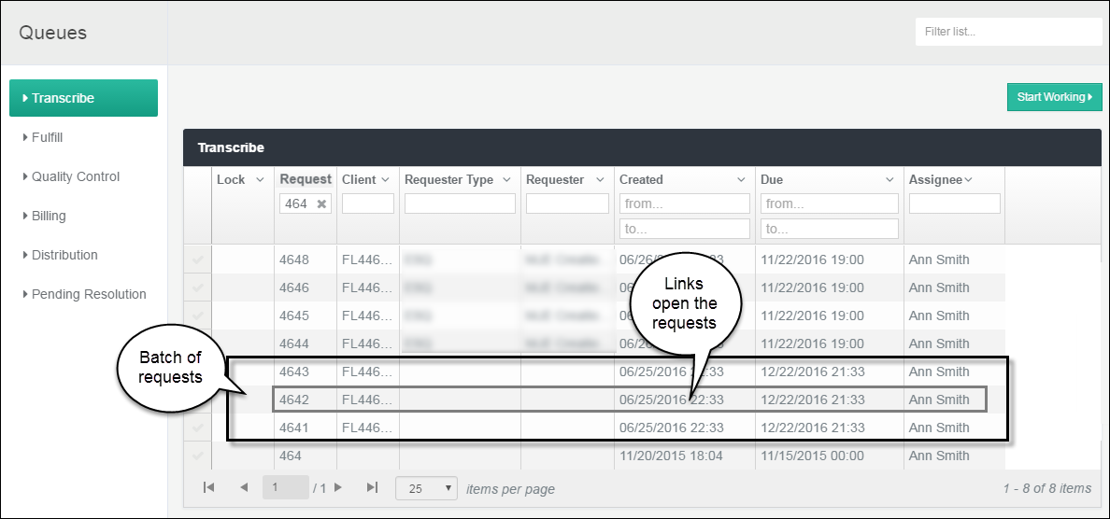
The request numbers are consecutive. Every request is assigned the same client, create/due date, time, and priority.
Open each request to complete the transcription. To return to the request page, click any column in the row of request details. Every column is a hyper-link that opens the respective request page. You can continue to add or to revise requests until complete.

Batch – Spreadsheet of Requests
This section describes the steps for uploading and creating multiple requests from a single spreadsheet. The uploaded spreadsheet contains columns with all required request information.
Quick Steps

- Choose file | Click Choose Files to select a single spreadsheet from your shared drives and folders.
- Upload the spreadsheet | Click Upload Files to open and view the spreadsheet content in the Uploaded Files list.
- Edit Batch | Click Edit Batch to open the Create Batch Request… page.
- Create Request | Click Create Request to create a request number for every item in the spreadsheet and automatically place the requests in the Transcribe queue.

Upload Spreadsheet
Spreadsheets transmit multiple requests in a single file. HDS permits two file types: .xls/x Excel files and .csv files. (EPIC users transmit .csv files.)
Start the request from the + New menu on the page banner.
- Click the New icon to open the pop-up menu.
- Click the Upload Request icon to open the request page.
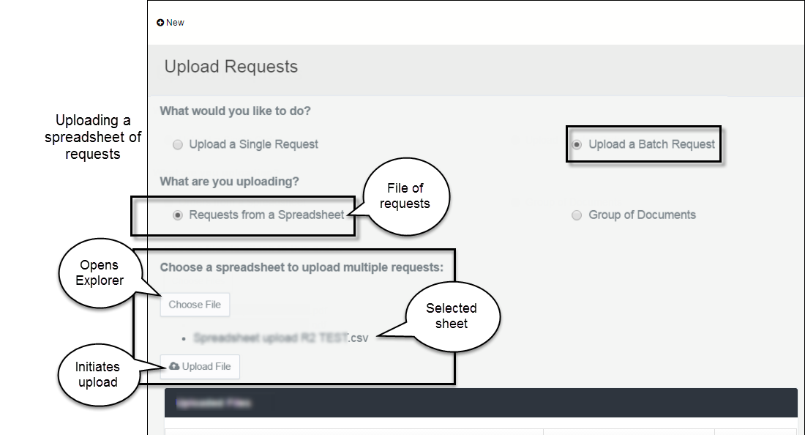
Requests from Spreadsheet buttons
Upload a Batch Request | In the section of the page titled What would you like to do?, select Upload a Batch Request.
Requests from a Spreadsheet | In the section of the page titled What are you uploading?, select Requests from a Spreadsheet.
Choose File | Click Choose File to open Windows Explorer on your computer.
If necessary, open the folder, then select a spreadsheet and click Open.
The Explorer window closes and the name of the selected Excel or .csv file appears as a bulleted list item below the Choose Files button.

To delete the selected file before upload, click the Choose File button. The Windows Explorer screen opens and the selected file is removed. You can select a file or Cancel to discontinue the request.

Upload File | Click Upload File to show the requests (content of the spreadsheet) in a list on the screen.

Required Information for Creating Requests
The headings highlighted below mark the information that the spreadsheet must contain.
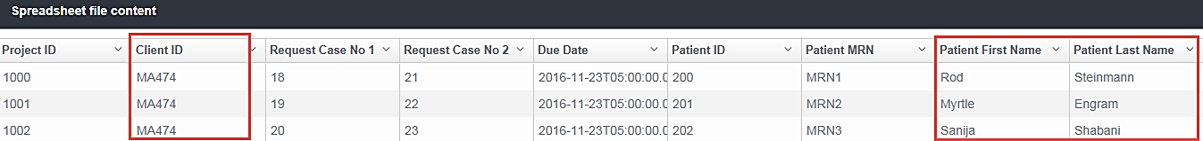
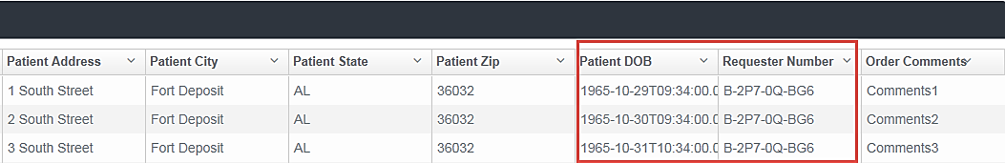

Viewing the batch list before creating the requests
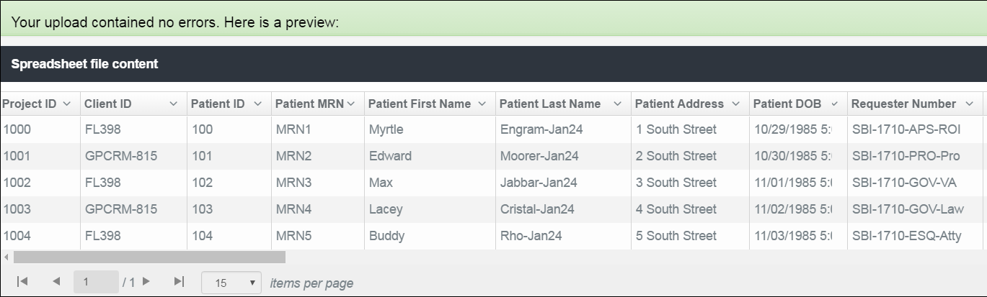
- To hide a column from view, click the Disclosure (down arrow) button in a column heading and select Hide Column.
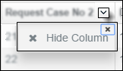
- To close the pop-up, click the small X at top-right in the button.
- To start the request process, click the Edit Batch button. The Create Batch Requests from Spreadsheet page opens.

Create the Requests
After successful upload, the Create Batch Requests from Spreadsheet page opens.
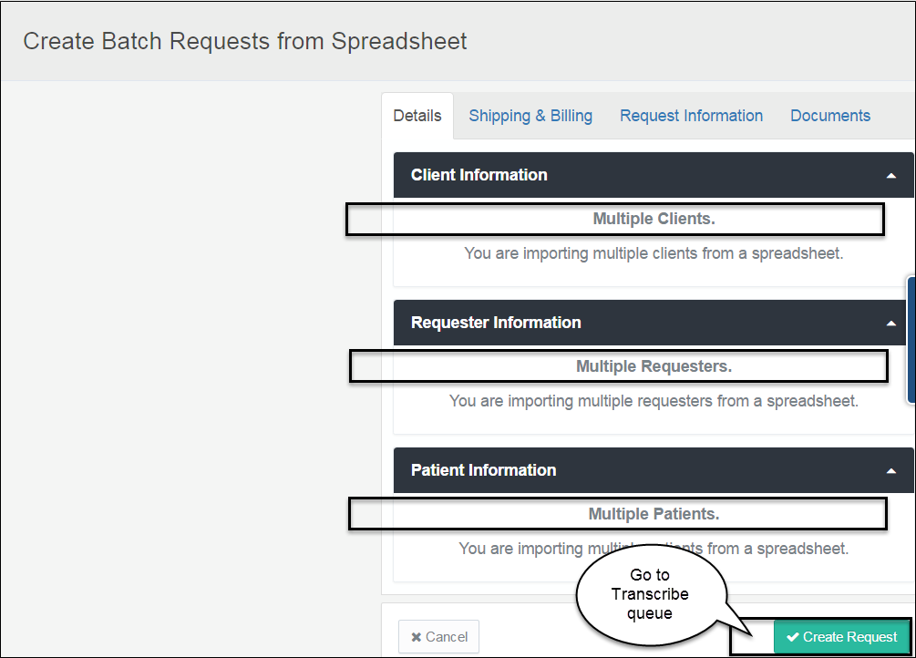
The Create Batch Requests page above represents a spreadsheet containing multiple types of information.
Request Details
Information fills in this page only if it is common to all new requests in the spreadsheet.
- Click Create Request to assign request numbers to each item in the batch and move the new requests to the Transcribe Queue.
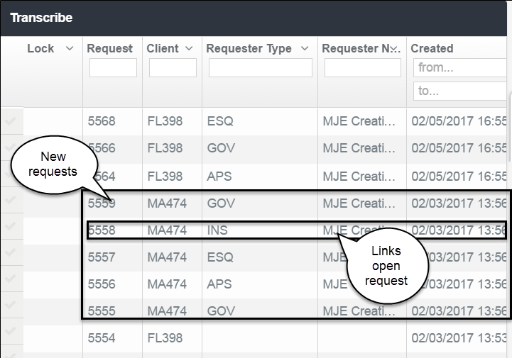
The request numbers are consecutive. All detail from the spreadsheet is uploaded into the requests, such as client, requester and requester type, due date, and priority. The system fills the create dates and times, and the assignee.
- To open an individual request and complete the details (Transcribe), click any column in the row of request details. Every column is a hyper-link that opens the respective request page.
The request summary appears at the top of each request page.
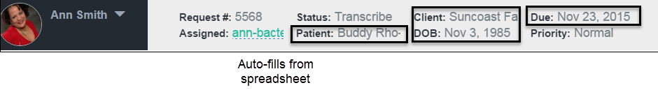
The Patient Information from the spreadsheet fills in the associated request. The Details tab is open.
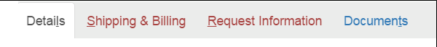
Depending on the content of the spreadsheet, the detail tabs in red indicate the initially required information. The fields in the tabs are marked with a red asterisk *.
- To add the supporting files, click the Documents tab.

Document Management
You can update documents at any time throughout the request process. From the request page, you can view and modify the documents until the request is considered complete and marked for delivery. Access to the documents and use of document management functions depend on the Queue in which the request currently exists and on the permissions of the current assignee.

Topics in this chapter
Viewing Request Documents
View the documents from the Request page or in the Document Viewer.
Working with Document Pages
Options available to existing pages.
Adding Files
Continue adding to the package after the request is created.
Versioning Files
HDS automatically creates versions after specific actions are taken.
Managing Request History and Notes
The system collects actions taken on each request. The system also stores notes with requests.
Setting Document Preferences
You can customize the document review tools to your preference.

View Package Documents
Every document (file) in the request is available for view. The system creates a tab (numbered at top left above the displayed page) identifying each individual document in the request: one Authorization document, one Abstract document, and individual Correspondence documents.
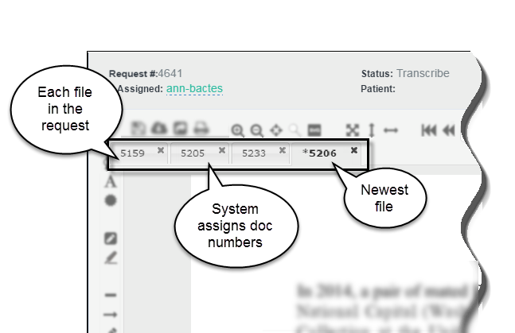
Numbered tabs | The repository assigns a unique number to each document at the time it is saved. These identifiers appear in the tabs above the page display space. The system-generated numbers are not formally associated with the request and they are not search-able.

Every request has 1 Authorization document and 1 Abstract document. All added files append the original document. Each piece of Correspondence creates a separate document.
To view a file in the request, click the ID number tab.

Document Viewer (Virtual Viewer)
The Viewer opens the document, thumbnails of its pages, and document tools in a new window.
To view files in the document viewer, click the viewer icon. (The button is at far top-right on the Request page, below the Search box.)
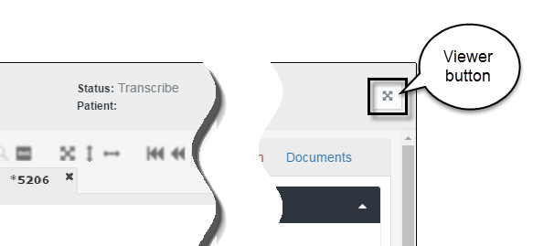
Narrow the number of package documents in view
By default, all documents in the request are available for viewing.
- Click the Documents tab in the details frame. Notice that all documents are automatically selected (check marked).
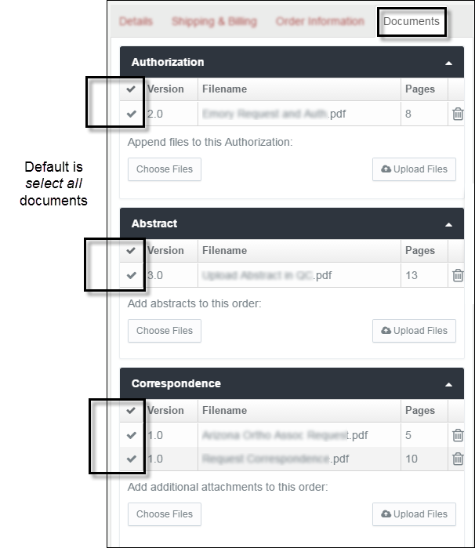
- Click each file to un-check it, leaving only the file you want to view.

Work with Pages
This section provides tips about navigating request pages and acting on page content.

Shortcut keys
When a request is open on the screen, you can move through the form without using the mouse. Like Microsoft Windows, HDS identifies the keyboard shortcuts by an underlined alphabetical letter in the label. The example below is the set of detail tabs in the Create Request page.

Document detail tabs
Move between tabs and tasks by pressing these keys.
Details tab | ALT+L
Shipping and Billing tab | ALT+S
Request Information tab | ALT+R
Documents tab | ALT+T

Document view and navigation
Press keys Ctrl + / to see the list of keyboard shortcuts, like the example below.
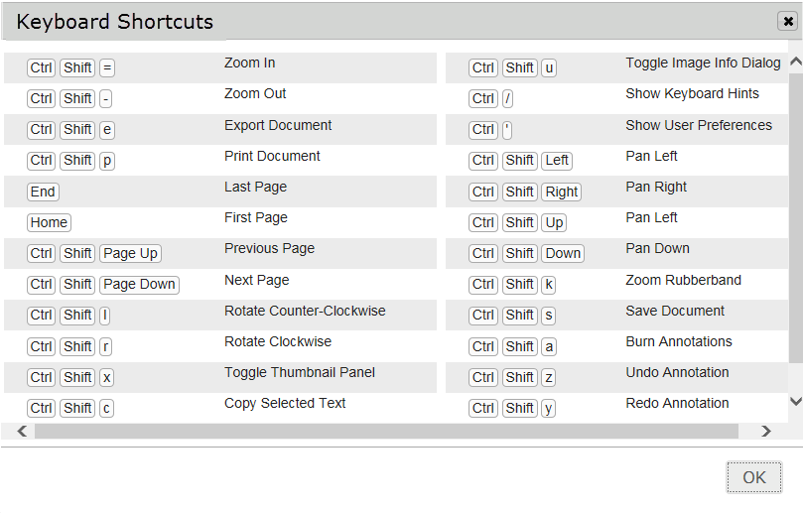

Page actions
The menu below shows the options available for use in pages.
- To open the menu, right-click the page in the thumbnails list.
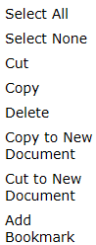
These functions are standard editing options. For use in requests, the actions apply to pages, not to the content of pages.

Actions affecting page count
Actions such as delete, copy to new document, and cut to a new document create a new version of one or more documents. (See the section Create File Versions later in this chapter.)

Delete Page
To delete, select a page (or more than one by holding Ctrl) from the thumbnails frame and click the Delete key. The Delete Pages dialog box opens.
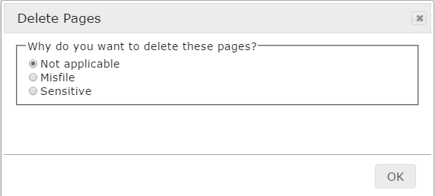
If reason is Misfile, enter the Patient Details in the text boxes.
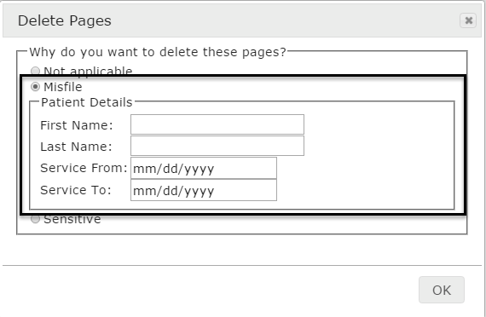
- Type in patient name. A calendar picker is available from the Service From and To date fields.
- Click OK.
If reason is Sensitive
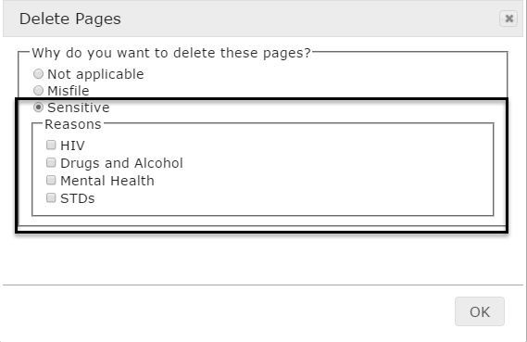
- Select one or more checkboxes that apply.
- Click OK.
Click the Save Document icon to make the delete action final.
The system updates the Documents tab.
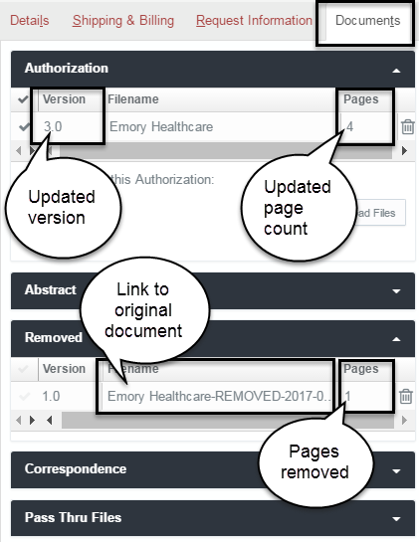
- Document version increments by 1 and the page count is reduced.
- Document name (link to the original version) and the number of pages deleted appear on the Removed list
Note: The process of deleting a page can affect non-.pdf file conversion. See the section Add Other File Types for a warning about taking the two actions simultaneously.

Add Files
This section describes the steps for adding files to a request.
On the request page, select the Documents tab in the right frame of the screen.
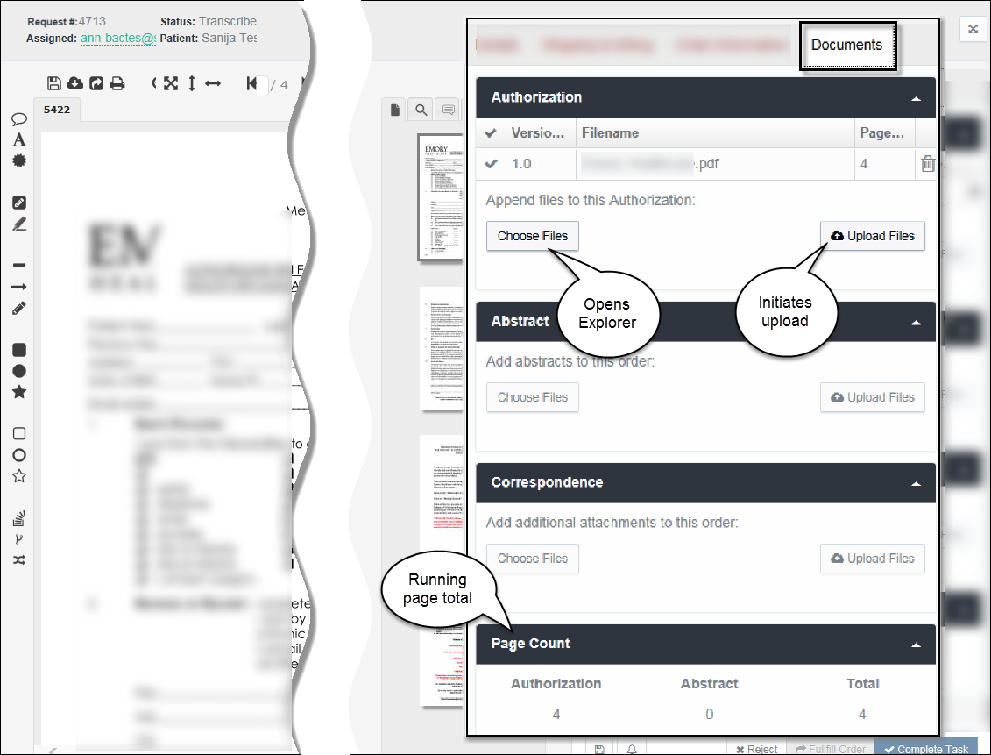
Add Document buttons
Choose Files | Click Choose Files to open Windows Explorer on your computer.
 | From a folder, select the file(s) for upload and click Open.
File Types
All documents in the request package must be .pdf files. You can upload other file types (such as Microsoft Office or graphics) and HDS will convert them to .pdf.
For further information, see Add Other File Types in this chapter.
 | The Explorer window closes and the name of the selected file(s) appears in a bulleted list below the Choose Files button.

To delete the entire selection of files before upload, click the Choose Files button. The Windows Explorer screen opens and the previously selected items are removed. You can reselect files or Cancel to discontinue uploading.

Upload Files – Authorization & Abstract | Click Upload Files to create (or append) one or more Authorization or Abstract files.  The individual uploaded pages appear in the thumbnails frame.
Upload Files –Correspondence | Click Upload Files to add one or more Correspondence files.
When adding files…
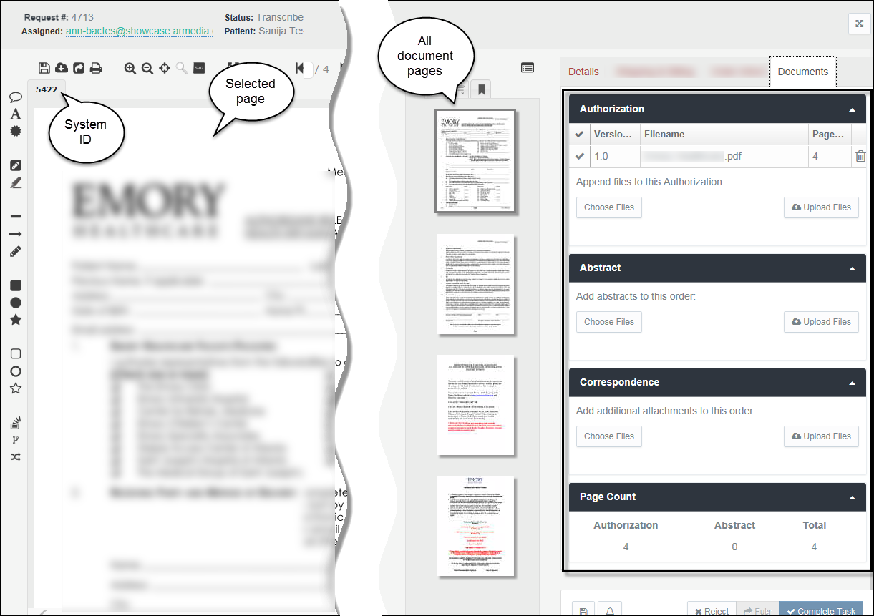

Document Type
Authorization | If no existing file, the uploaded document is added as version 1.
Abstract | If no existing file, the uploaded document is added as version 1.
 | If an Authorization or Abstract file exists, the uploaded document appends the existing document—its pages are added to the existing pages. The document version will increment by 1 (or by the number of files added).
Correspondence | All files are added as separate documents.

Add Authorization Documents
You can upload more than one file. If you are creating a new Authorization document, the file name defaults to the first file in the batch.
HDS orders the files as they appear in Windows Explorer. By default, files in Windows Explorer folders list in ascending alphabetical order. When the folder opens in your Explorer window, sort the files before selecting and uploading to create the file name you want.
Files added to an Authorization append the existing pages.
Record of Authorization document
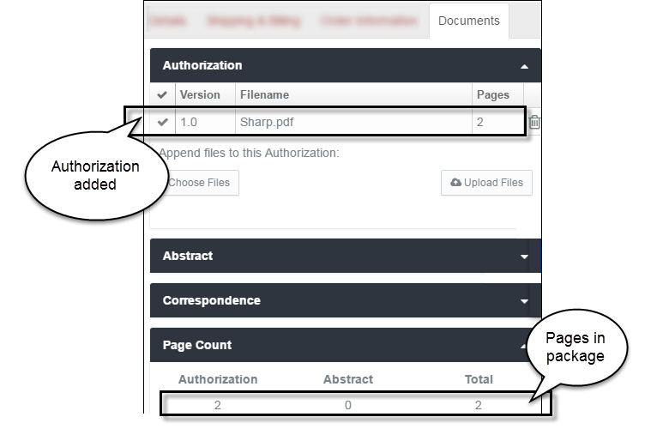
The additional pages are visible in the thumbnail frame. The pages are placed after the existing pages.
File status
Version | The Version of the new Authorization file is 1. When uploading multiple files, the version increments by the number of documents added. For example, adding four Authorization files in the initial upload will automatically create version 4.
Filename | The Filename will not change, it remains the name of the original, or first, uploaded file.
Pages | The Pages count increments by the number of pages added to the file.

- To remove the file from the request, click the Delete (trash can) icon.

Add Abstract Documents
You can upload more than one file. If you are creating a new Abstract document, the file name defaults to the first file in the batch.
HDS orders the files as they appear in Windows Explorer. By default, files in Windows Explorer folders list in ascending alphabetical order. When the folder opens in Explorer, sort the files before selecting and uploading to create the file name you want.
Files added to an Abstract append the existing pages.
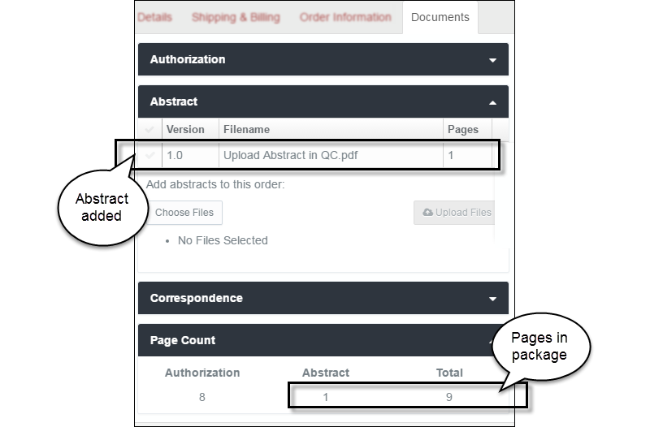
The additional pages are visible in the thumbnail frame. The pages are placed after the existing pages.
File status
Version | The Version of the new Abstract file is 1. When uploading multiple files, the version increments by the number of documents added. For example, adding four Abstract files in the initial upload will automatically create version 4.
Filename | The Filename will not change, it remains the name of the original, or first, uploaded file.
Pages | The Pages count increments by the number of pages added to the file.

Do you want to remove a file from the request?
Click the Delete (trash can) icon corresponding to the file name.

Add Correspondence Documents
Each new Correspondence document is added as a separate file.
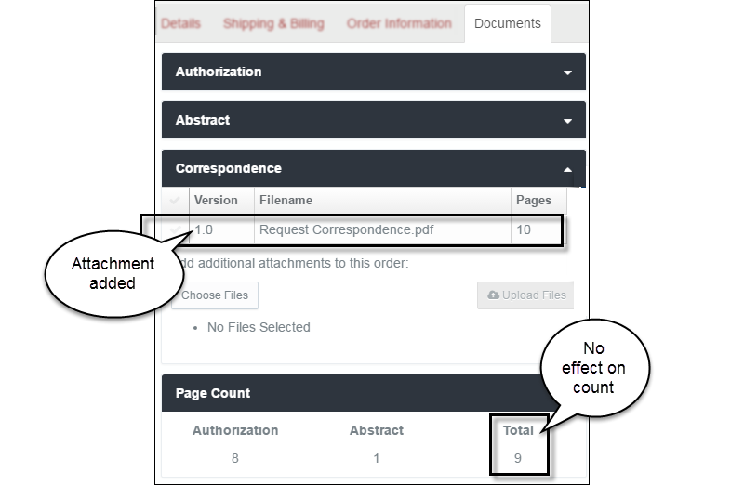

File status
Version | The Version of added Correspondence is always 1.
Filename | The Filename column is a record of each Correspondence document. You can add multiple documents at a time, which are individually added to the Filename list.
Pages | Correspondence does not affect the package Page Count.

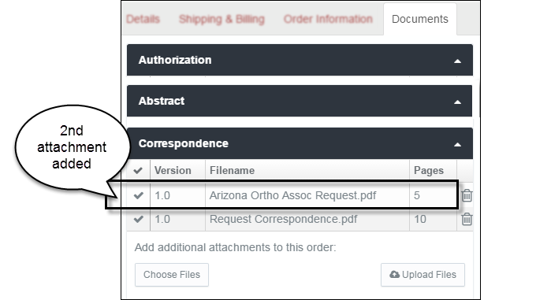
Do you want to remove a file from the request?
Click the Delete (trash can) icon corresponding to the file name.

Add Other File Types
All documents in the HDS request package are .pdf files. When you upload other file types—such as Microsoft Word, PowerPoint, Visio, and Excel; graphics; or .tiff/.tif — HDS converts them before opening a new request page, appending an existing document, or creating new correspondence.
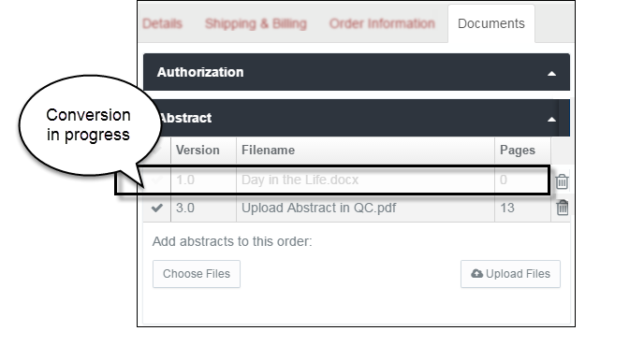
The conversion is not instantaneous. Expect the file to convert and load in 1 to 2 minutes.
During the process, the file name appears dimmed on the Filename list. When the conversion completes, the file name disappears and the pages append to the existing file or a new Correspondence document is added.
Warning: converting a file and deleting a page…
Wait for the conversion to complete before you delete a page from the file you are appending. A page delete prevents the conversion from completing and prevents the pages from being appended to the existing file. The interruption to the conversion, however, does not prevent versioning. The version will increment by one even though the file was not updated. (See Create File Versions, the next section, for guidelines on document versioning.)

Create File Versions
This section describes the actions that create versions of files.
- Append files
- Annotate files
- Change the number of pages in a file
Open the request. Select the Documents tab in the right frame of the page.
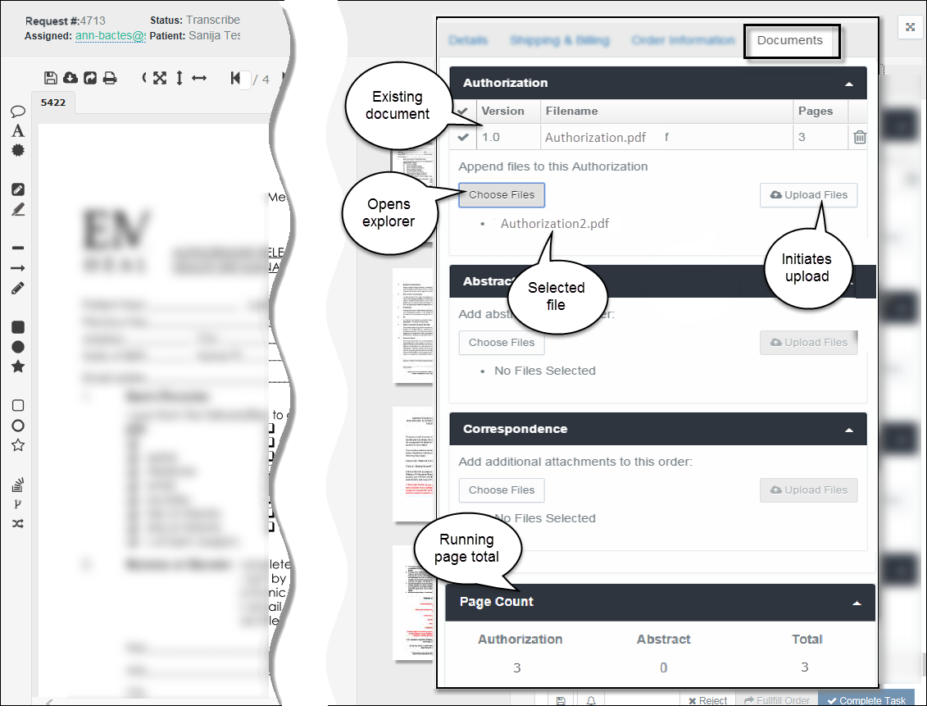
In this example, an Authorization document exists. Two actions create new versions of a document: Append and Edit (Save or Burn).

Create Version - Append File(s)
File appending applies to Authorization and Abstract documents. When you add a file, you are inserting the pages from the file into the request package.
- Uploading one file increments the version number by 1.
- Uploading multiple files increments the version number by the number of documents selected. Four documents uploaded to a version 1 file creates version 5.
For further description of appending files, please see the section Add Files.
Authorization and Abstract Documents
Document detail buttons
Choose Files | Click Choose Files to open Windows Explorer on your computer.
From your drives and folders, select one or more files for upload and click Open.
The Windows Explorer screen closes and the name(s) of the selected file(s) appears as a bulleted list item below the Choose Files button.

To delete the entire selection of files before upload, click the Choose Files button. The Windows Explorer screen opens and the previously selected items are removed. You can reselect files or Cancel to discontinue uploading.

Upload Files | Click Upload Files to append the Authorization or Abstract file.  The file(s) pages appear in the thumbnail frame, after the existing pages.  The version of the file increments by 1 (or by the number of files uploaded).

The version and the page count updates.
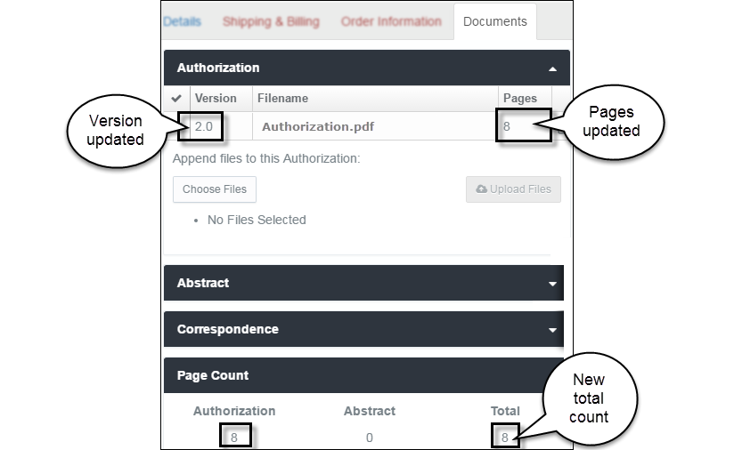

Create Version – Annotate File
From the Request page, you can create, share, save, and burn a variety of document annotations.

Annotation Options
Open the request. The document most recently added to the request appears in the content space.
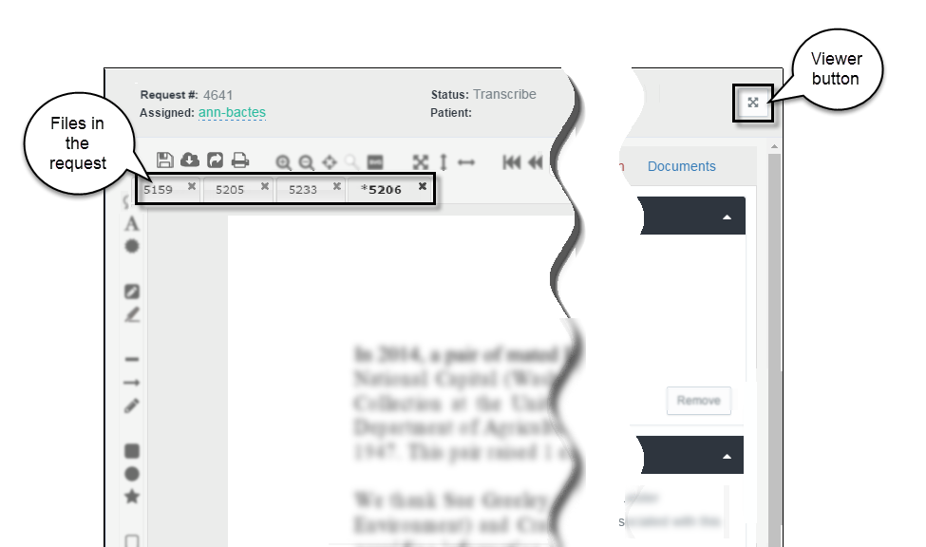
A set of annotation tools is available for marking up pages. The tools appear on the left pane of the request page in the document viewer (virtual viewer).
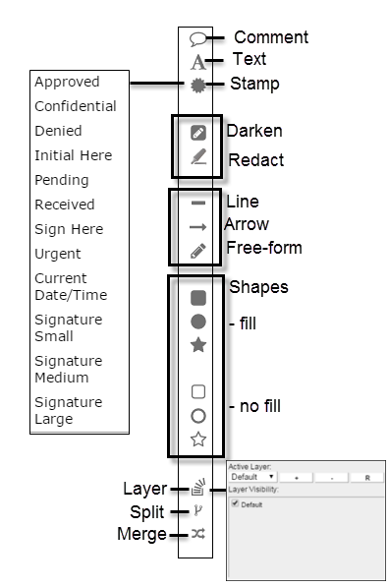
Each authorized reviewer can insert comments, highlights, and redactions for view by other authorized reviewers.
Note: Annotations added to documents in the Transcribe queue must be saved/burned for other reviewers to see them.

Arrow Annotation
When the user selects it, the arrow annotation remains active until another annotation is selected.
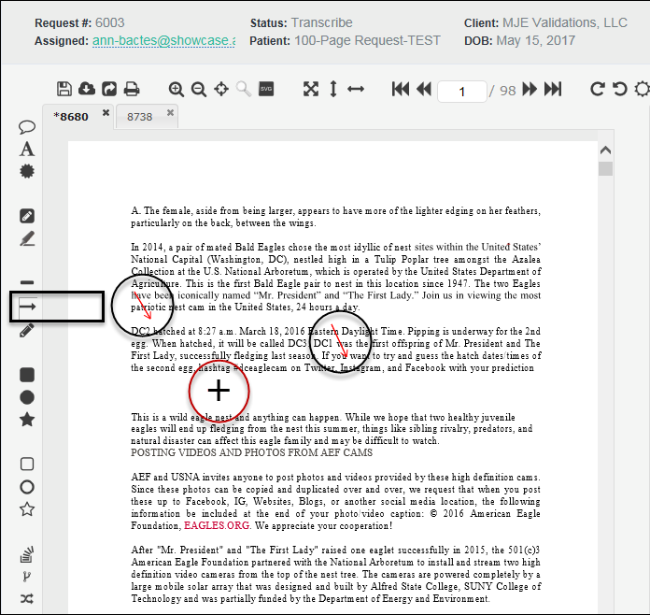
Any number of arrows can be added to the page or document without need to reselect the arrow icon. Once a document is in the QC stage, annotations are burned in and cannot be removed.
Save and Version
Annotation action buttons are at the top of the content space, above the document identifier tabs.
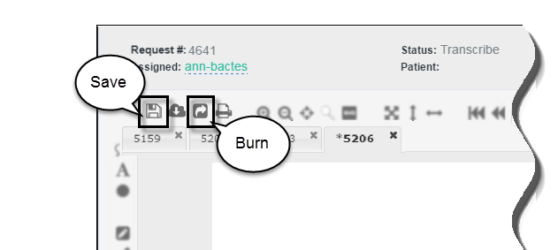
When markup is complete, click Save Document (to save annotations within the virtual viewer) or Save Document and Burn Annotations (annotations will print in the request package). Saving creates a new version of document. Page annotation is also available to Correspondence pages.
Note: Manual Save/Burn of annotations is required only in the Transcribe queue. Annotations are automatically burned when documents are in the Quality Control queue.

Create Version – Change the File Page Count
You will create a new version of a document when you:
Delete a page from a document | Increments the version and changes the page count
Cut a page and add it to another document | Increments the versions of both documents and changes the page count of both documents
Copy a page to another document | Increments the version of the destination document and changes the page count of the destination document

Manage History and Notes
HDS automatically records all actions taken on a request. Authorized users can attach notes to the request and make the notes available for other users to view.
The two tabs appear at the bottom of the document view space on the request page.
I don’t see these tabs on the page.
If the tabs don’t appear on the screen, they are hidden below the frame of the page. Go to the lower border of the page and click/scroll below the page display space.
The browser you are using (such as Internet Explorer, Chrome, Firefox) and the zoom setting of the browser (such as 75%, 100%, 125%) affect the appearance of these tabs on the page.

Request History
All request “events” are collected in a list. Your system administrator designates the actions to track.
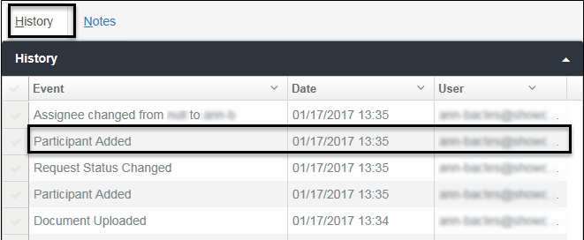
The History list identifies the event, the date of the event, and the user who took the action. The content is strictly for information purposes. No links or other uses are available.

Request Notes
You can attach notes to a request. Notes create a record that is available to other people with access to the request.
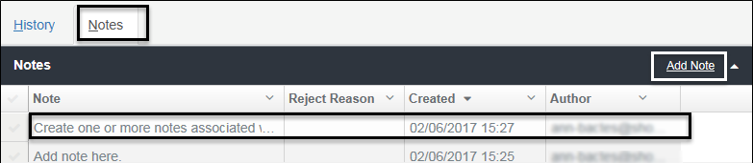
The screen shows the content of each note (truncated if too long for the description field), the date of the note, and the author of the note.
Reject Reason: A reason is required when rejecting a request. Rejection descriptions and reasons store in the Notes list.
To create a note, click the Add Note link on the title bar. A free form space opens for typing the description and saving (or canceling) the new note.
Sorting the History and Notes Lists
To reorganize the list, click the Disclosure (down-arrow) button in a column heading to select an option.
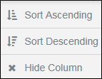
The default sort normally is descending by date/time.

Set Document Preferences
You can create your own settings for the tools and screen display in the document viewer. You can create settings for:
- Toolbar
- Annotations
- Custom text stamps
- Display size
- To personalize document review settings, open a request.
- From the action buttons above the document content space, click the User Preference icon.
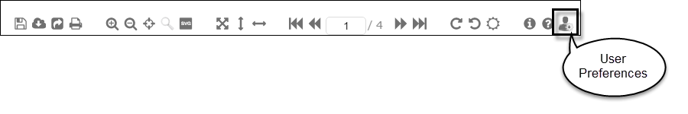
- Click the tabs to set various doc review options.
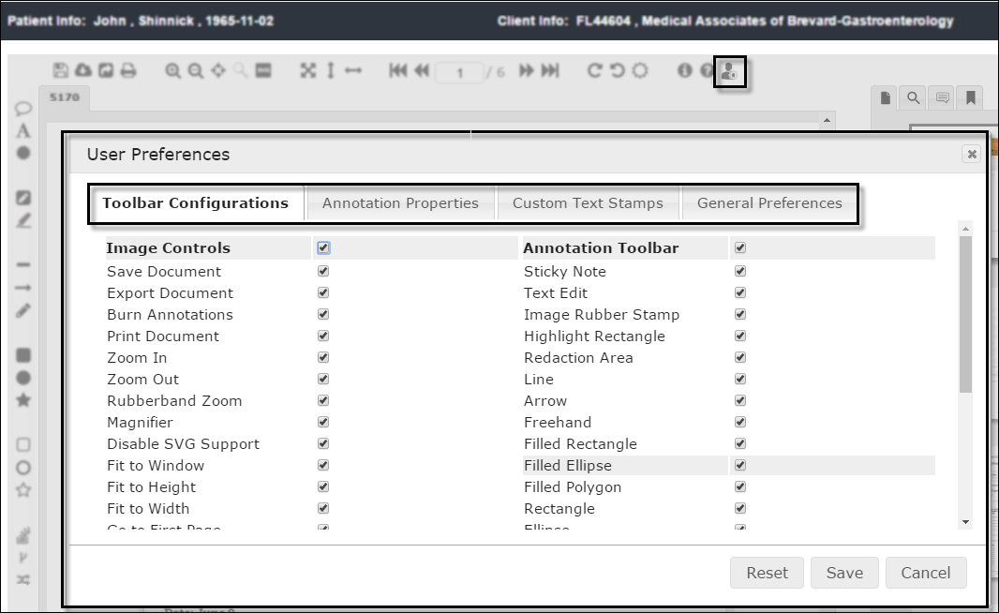

Toolbar Configurations
All toolbar options are selected by default (screen shown above).
Unselect any of the tools you do not want to appear in your version of the virtual document viewer.

Annotation Properties
Create settings for the annotation tools.
- Select each Annotation Type you want to customize.
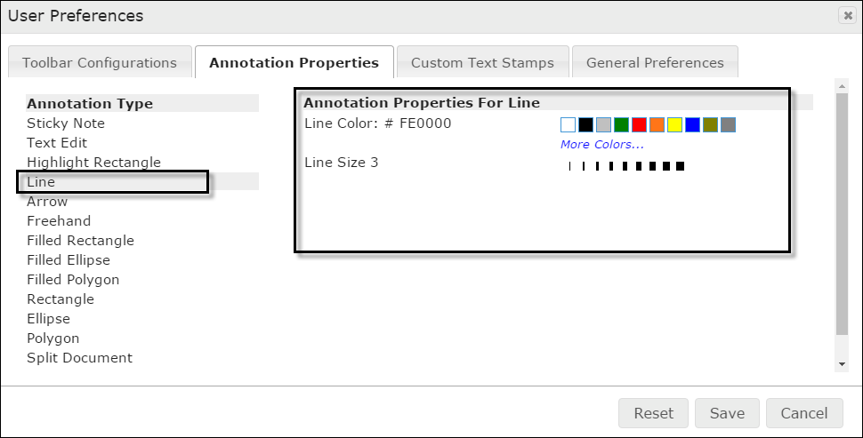
- When the type is selected from the list, define the new properties using the setting on the right side of the screen.

Custom Text Stamps
Create your own stamps.
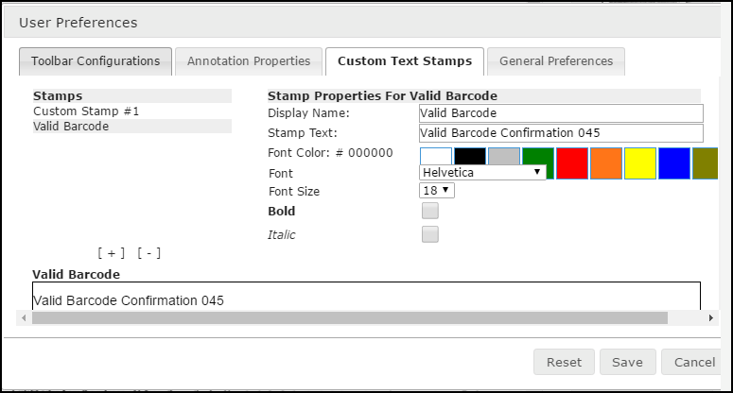
- Click [ + ] (bracket plus sign) to create a new stamp.
- Type a name for the stamp in the Display Name field in the properties section at right. The name appears in the Stamps list.
- Type text that the stamp will display in the document.
- Define the font, if needed.
- To delete a stamp, highlight it in the Stamps list and click [ - ] (bracket minus sign).

General Preferences
Change the display-fit and user name settings.
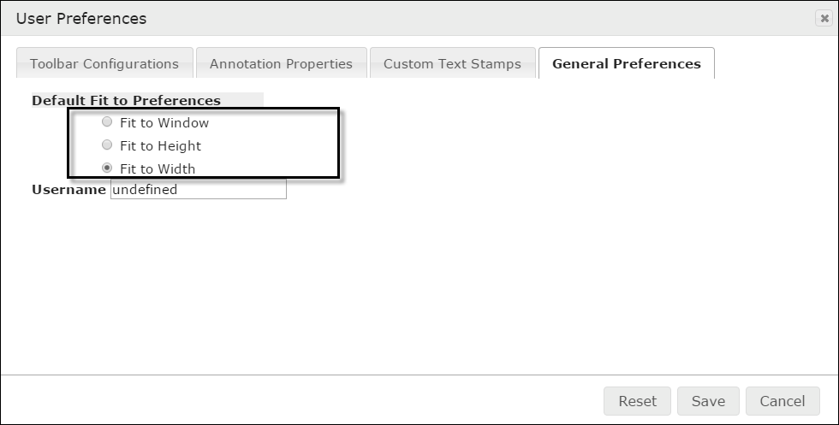
Click in a radio button to change the default document display.

Saving and Resetting
- Click Save to make the changes effective.
- Click Reset to change the settings to the previous selections.
- Click Cancel to close the window without saving.

Search
HDS makes available global search of all in-progress and archived request records. The search initiates:
- User-defined search
- Pre-defined search
- Client and Requester search
- Queue content search
You can create specific searches by entering whole words and numbers or filtered searches by entering partial words and numbers in the Search free-form text box.
Search facets accompany the results. These filters provide a way to narrow broad sets of results.
When running searches, you have access only to those results that you have permission to see.

Topics in this chapter
Create a global search
Using the search text box in the page banner.
Filter pre-defined results
Using the Search module to locate content.
Search clients and requesters
Using search to locate organizations and auto-fill its information.
Options for the search results
Viewing, organizing, and saving search results.
Search queues
Locating and grouping queue content.

Global Search Text Box
Use the Search box to define a search. The text box is in the page banner and available anywhere in HDS.
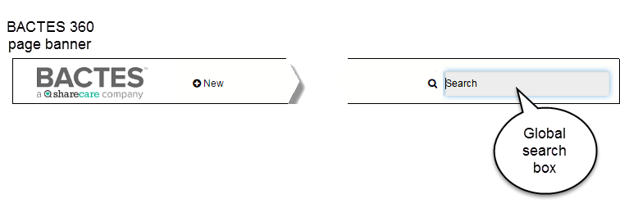
- Type at least three letters or numbers for general searching. The results will include every instance of the search request it finds in the repository.
Wild Card
Use of the wild card—the * asterisk—gives you further search options. The minimum requirement for a search request is three characters (letters or numbers). Two letters or numbers plus the asterisk (ja* or 48*) searches for all instances of the two characters—results beginning with, ending with, or otherwise containing.
Examples of
search request
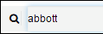 | A search for full name returns only instances in which the name appears as entered.
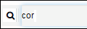 | Shortened name returns all instances (in names and within requests) of these three letters.  Same rule for search of numbers. All instances of three, four, or more numbers in requests, cases, identification, phones, faxes, addresses, dates, and times.
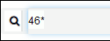 | Use the * to search for one or two characters or numbers. In the example, for all numbers including the digits 46.

- To start searching, click Enter or the magnifying glass icon. The Search module page opens with the Results.
For a look at the results page, see the Search Results section below.

Search Module
The Search module initiates a pre-defined search. When you click the Search tab in the Navigation frame, it automatically lists all available, searchable data in the repository.
- Click Search from the Navigation frame to open the module.
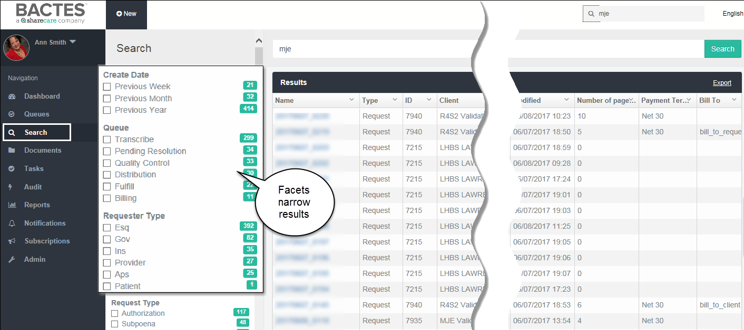
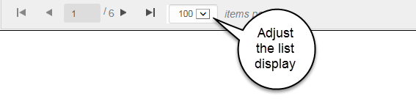
The results you see are collected only from those organizations with which you are authorized to work.
For a look at the results page, see the Search Results section below.

Client and Requester
Requests require client and requester. Employees with broad permissions—that is, having access to most or all the CMR database—can use a special search to locate and upload these associations.
Employees with limited permissions see a pre-defined search results list of those organizations with which they are authorized to work.
This search initiates from the Details section (Client or Requester) of the request.
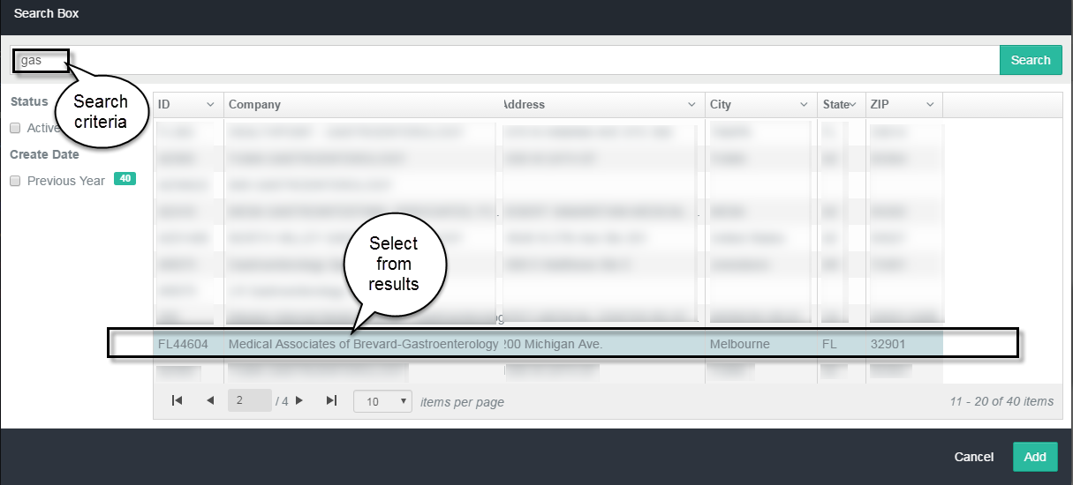
The standard rules apply when defining the search: the request must contain at least three characters.
If multiple results return, click to select the correct item from the list and click Add.

Search Results
The options for reviewing search results are similar, regardless of how the search initiates.
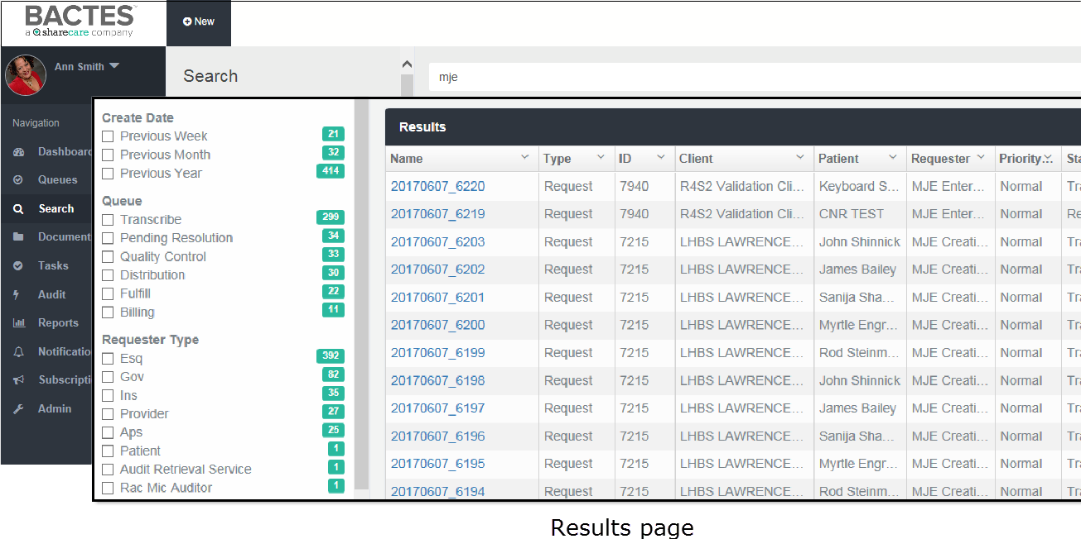
The results organize in the following columns.
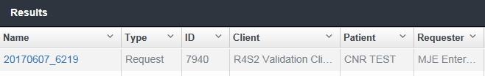
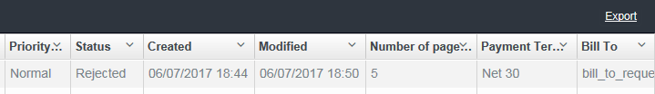
Not all search results return these identifiers.

Filter the list
Along with the search results, a set of corresponding facets displays in the Browse frame.
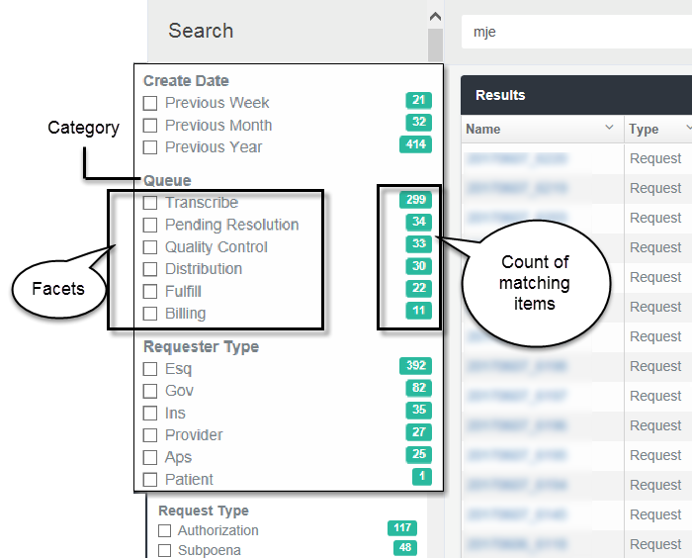
Facets are like filters. Use one or more facets to narrow the number of results that display. The facets you see vary by the search results and by the previous filter. Each facet shows the number of results that correspond to that filter.
  - Select or clear the facet check box(s) to create a filter.
The list of results will adjust as facets are added or removed.

Find specific results
When a set of multiple results returns, you can conduct a search of the search results.
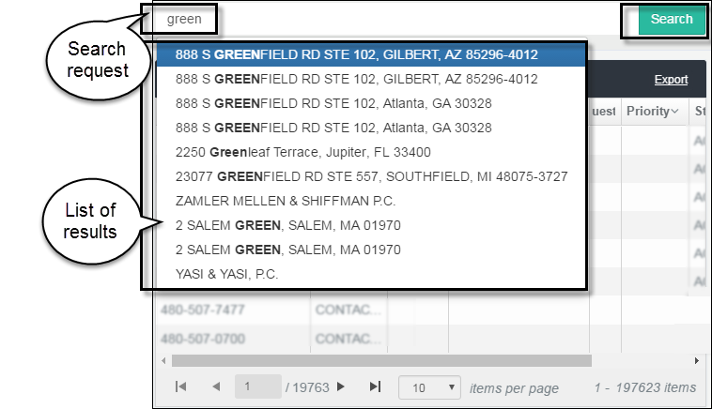
- In the text box above the results, type criteria for the search.
As you type, the system may predict your search in a list of matching results.
  - If the predictive list contains the specific result you want, select the item from the drop-down list.
  - If you want a broader group of results, click Search.
The set of results will adjust to the list option you choose.

Re-order the list
You can change the sequence in which the results list in the space. The options are available in each column of data.
  - To sort the list of results, click the Disclosure (down arrow) button in a column heading.
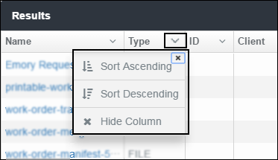
  - Sort the list in Ascending order (A-Z, 1-x) or Descending order (Z-A, x-1) of the selected column.

Hide a list column
  - To hide a column from display, click the Disclosure (down arrow) button in a column heading.
  - Click Hide Column to remove it from view.

Adjust column width
You can widen (or narrow) the size of any column in the results list.
- In the header row at the top of the list, place the cursor on the column border. The cursor will change to a double arrow.
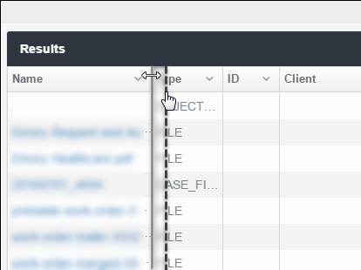
- Drag the line to the right or left to adjust the width.

Adjust the list size
The default number of list items on each search results page is 10. If your preference is to scroll a list rather than move between pages, you can increase the number of list items that appear on the screen. Likewise, you can show fewer items on each page.
- To increase (or decrease) the number of results you want to see on each screen (page), scroll to the bottom of the results list.
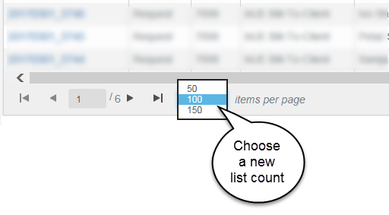
The default display setting for the results list is 100 items per page. You can change the count to 50 or 150.
- Click to select a new count. The selection drop-down closes and the list length adjusts to the new size.
The change to the list count is active only for the current session. The count resets to the default when you leave the Search screen.

Navigate the list pages
To move between pages of results, use to GoTo arrows at the bottom of the list.
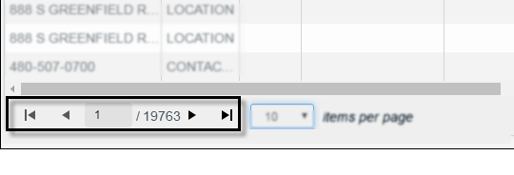
- Right arrows move forward: Click to open the next page, or | to go to the last page of the list.
- Left arrows move backward: Click to open the previous page, or | or to return to the first page of the list.

Export results
You can export the search results list to a Microsoft Excel spreadsheet. Once in a spreadsheet, you can use all the Excel tools to manipulate the content.
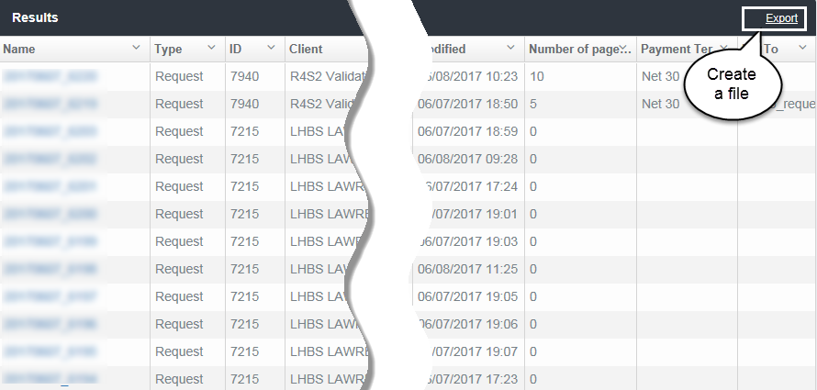
- When you have created the set of results you want, click Export.
HDS exports the results to a comma separated values (CSV) file.
File name
The system assigns a generic name to the file, for example, undefined and the date.
- When the prompt appears at the bottom of the screen, choose an option.
  - Open the file
  - Save – Save and location, Save As and location, Save and open.

Queue Search
You can use the text fields in the Queue column headings to filter content or locate specific content. The rules for filtering and searching vary slightly by column.

Request column
Enter one or more numbers in the column search box.
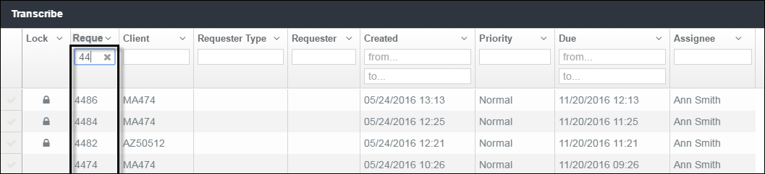
Filters a group of requests or locates a specific request.

Client column
This column requires entry of the complete client identifier.
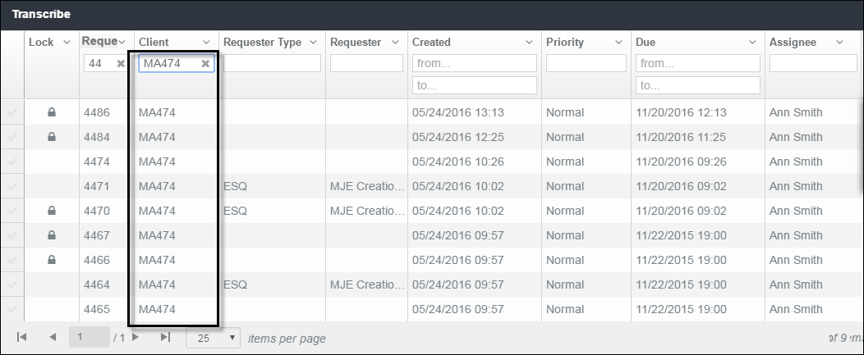

Requester columns
Partial entry is acceptable to retrieve requester information.
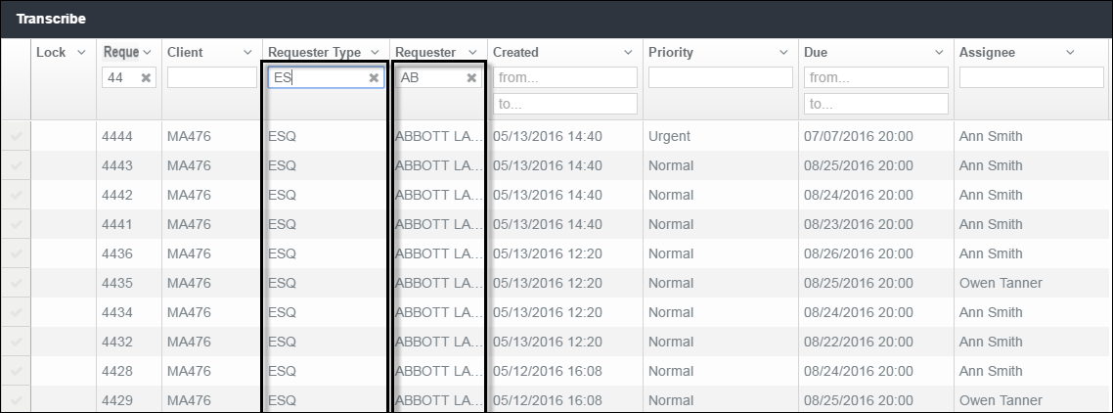

Date columns
Type in the full dates.
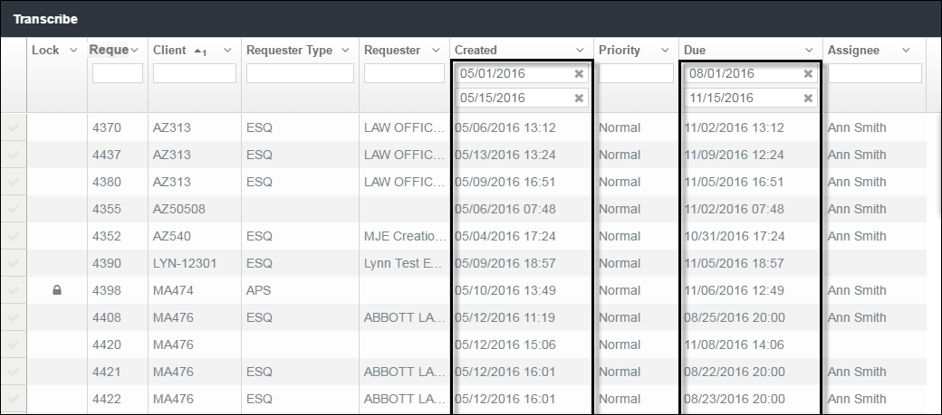
Filtering by date requires full entry of either or both Created and Due dates. Date range requires at least a one-day time span.

Priority column
Filter the list of requests by priority.
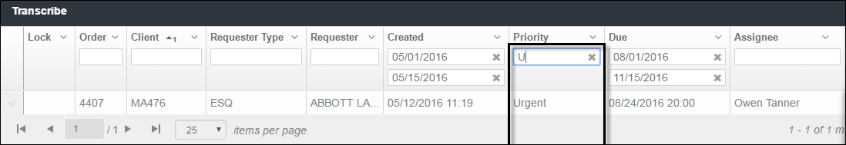

Assignee column
View requests by assignment.
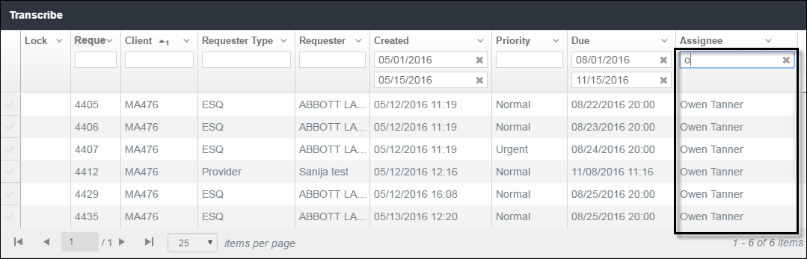
Begin typing a name to filter by assignee. Field is not case-sensitive.

Reports
HDS currently makes available the Turnaround Time by Requester report. Not all people have permission to run the report of clients.

Topics in this chapters
Define a report
Steps for creating a set of results.
View report results
Options for organizing and navigating the report.
Create a copy of the report
Steps for saving the report as a separate file.

The Reports Page
The Reports module lets you choose the clients and date range for a report.
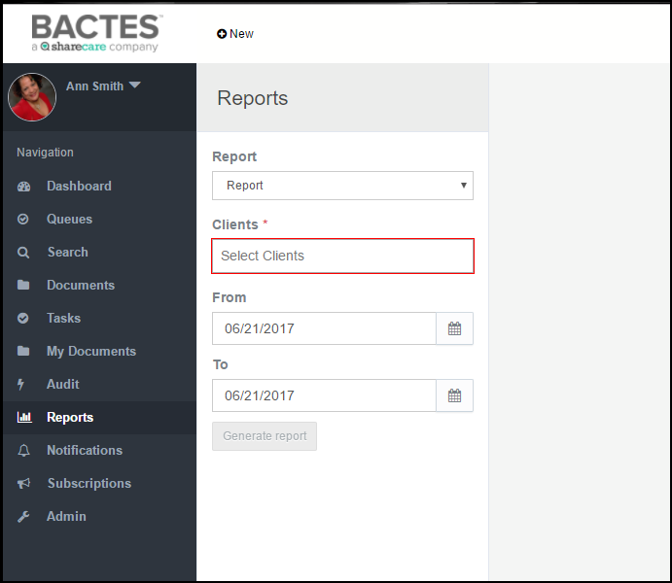
Search criteria are created in the Browse frame. The Generate report button is enabled only when required fields are complete.

Define a Report
The report request criteria allow you to tailor results, and conserve search time and the amount of physical data returned. All fields are required. That includes the Report (name) field.
- In the Report field, select Turnaround Time by Requester report so it appears in the field.
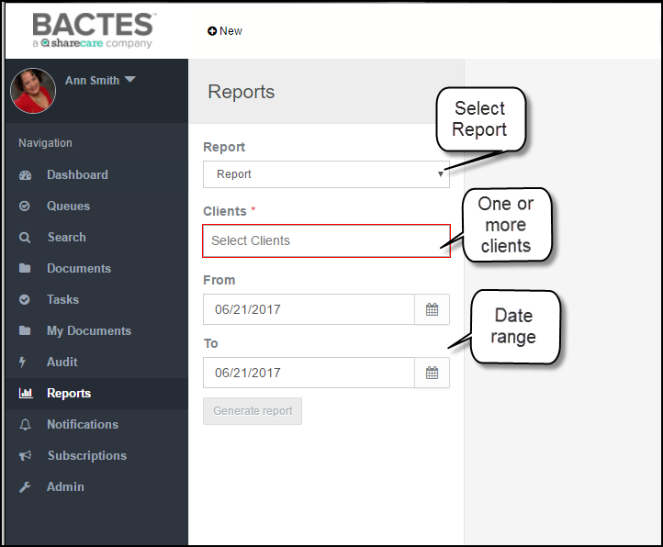
- Click in the Report field and select Request Status or Turnaround Time by Requester.

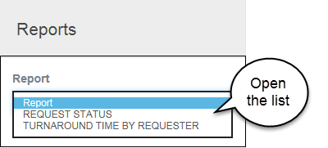
Even though the Report field does not indicate required (red outline or asterisk), the report name must be selected and appear in the field.

- Click in the Clients field and start typing a name or client number. It’s a predictive entry field so the system collects a list of potential matches. When the correct option appears in the list, click it to move the name into the field.
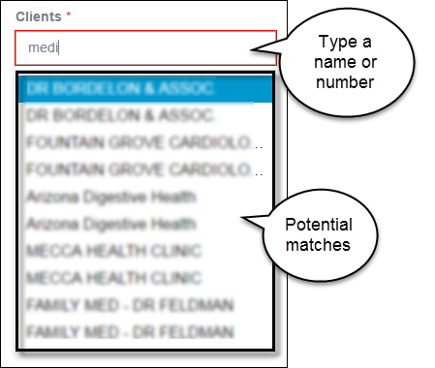
- To report on more than one client, start typing the next name or number and select it when it appears on the drop-down list of potential matches.
- Use the Date Range fields to confine the results to a period. (The default is today; leaving it as-is returns one day’s results.)
- In the From and To boxes, enter, or select from the calendar, a date range.
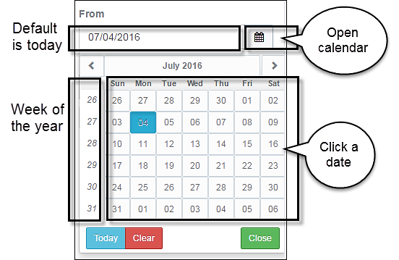
- If manually entering, follow in the same format as shown in the field: MM/DD/YYYY.
- To select the date for either or both fields, click the date picker icon to open the calendar.
The buttons in the month title panel open the previous |<| month or the next |>|month.
- Click Generate Report to return the results.
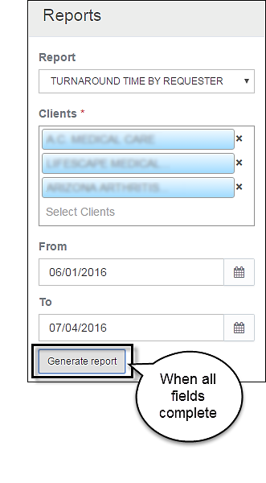
The report displays in the Detail frame of the page.

View Report Results
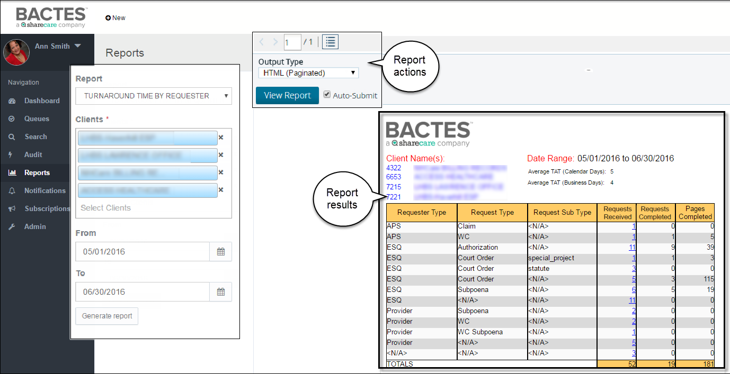
Report Actions
By default, the new report page makes available options for formatting and viewing the content. The group of options appears in the View Report panel above the report results in the upper-left corner of the Detail frame.
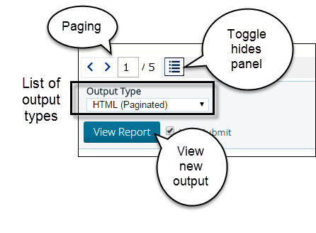
- Left and right arrows: click |>| arrow-right to move ahead one page in the results, click |<| arrow-left to go to the previous page.
- Number of pages in the report: shows the page of pages, for example 1 / 5, where you can enter a number in the box and jump to any page of the report.
- Toggle button expands the space for viewing the report. It hides (and redisplays) the View Report panel that appears above the report content.
- Output Type dropdown is a list of options for saving the report. Use the View Report button to see the report in the new file format.
Report Results
The report results show up to 20 list items on a display page.

Request Status Report
The Request Status Report will closely resemble the example below.
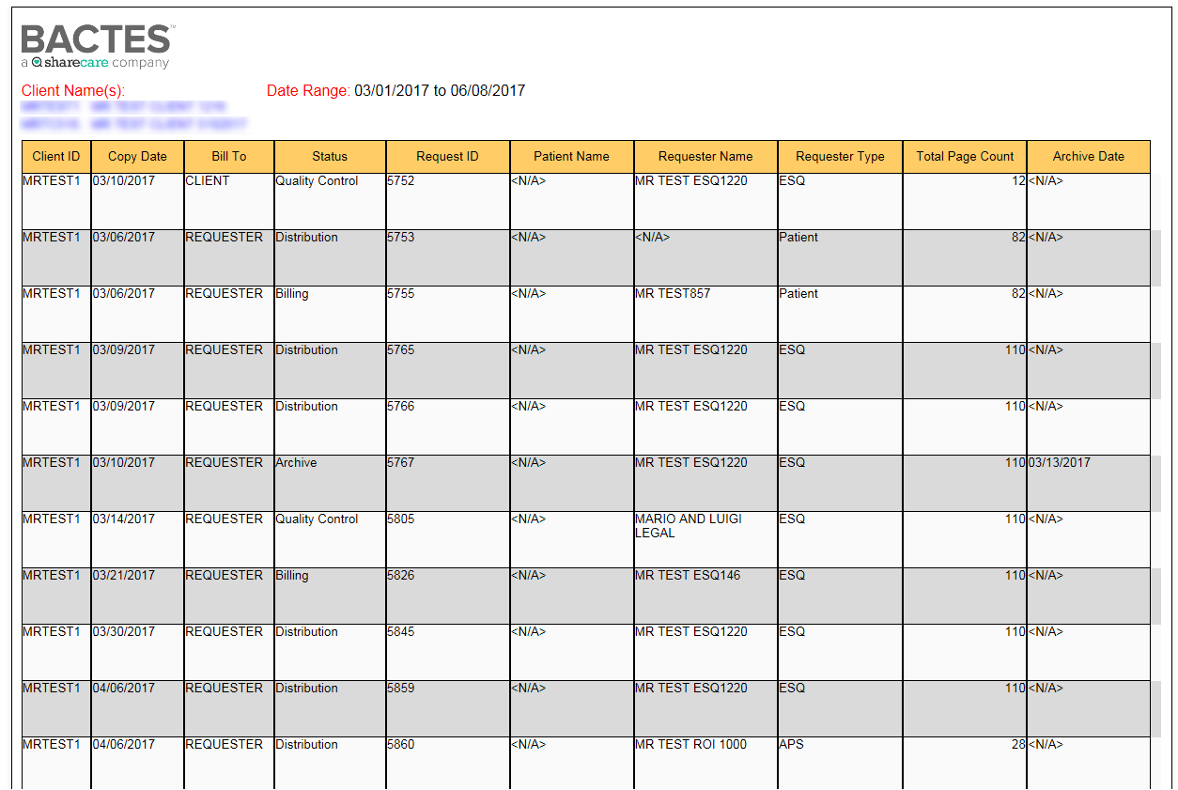

Turnaround Time by Requester
The Turnaround Time by Requester Report will closely resemble the example below.
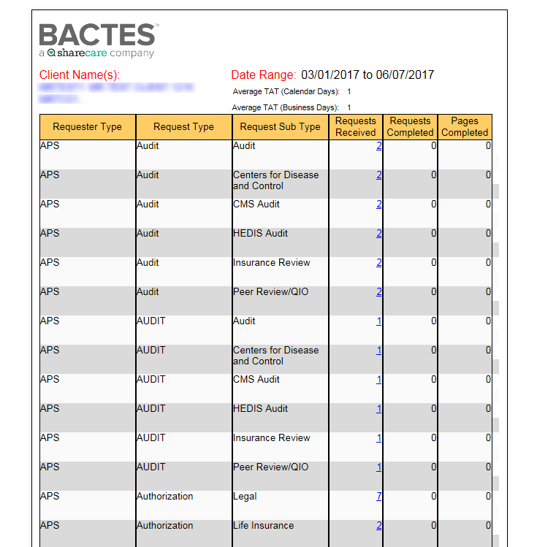

Report Web Viewer
A link in the Requests Received column of the Turnaround Time by Requester Report opens a status summary of each request received. The example below shows the content of the summary.
The example identifies one request that has been completed and is in archive.

Save the Report
The onscreen report results is a fixed display. It is an orderly presentation of the records collected from the database. As is, its content cannot be manipulated, copied, or printed from the page.
To create a copy of the report, save it in another format.
- Click in the Output Type field to open the list of available file types.
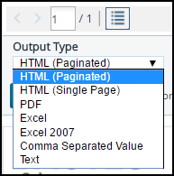
- Click to select a file type. If the new file does not open, click View Report.
- Save or view in the selected file format.
Output Type
The Output Type box is a list of options for making the content available for other purposes. The default display is HTML, in paginated form.
Formats | Results
HTML (Single Page) | Shows the onscreen results in a single-page, scrollable format.
PDF | Opens the results as a .pdf file, which you can save.
Excel | Creates a spreadsheet of the report, in which the content can be used like any other Excel file.
Comma Separated Value (CSV) | Formats the report in a spreadsheet, suitable for copying to a database or another environment.
Text | Creates a plain text file for use in generic text editors and utilities.

Audit
Authorized users can view all HDS system activity (events) associated with requests and files. The Audit module provides the capability for defining the audit and the options for saving the results.

Topics in this chapter
Define an audit
Steps for creating a set of results.
View audit results
Options for organizing and navigating the audit.
Create a copy of the audit
Steps for saving the audit as a separate file.

The Audit Page
The Audit module makes available a set of parameters for specifying the content of an audit. Define the audit completing the fields in the Browse frame.
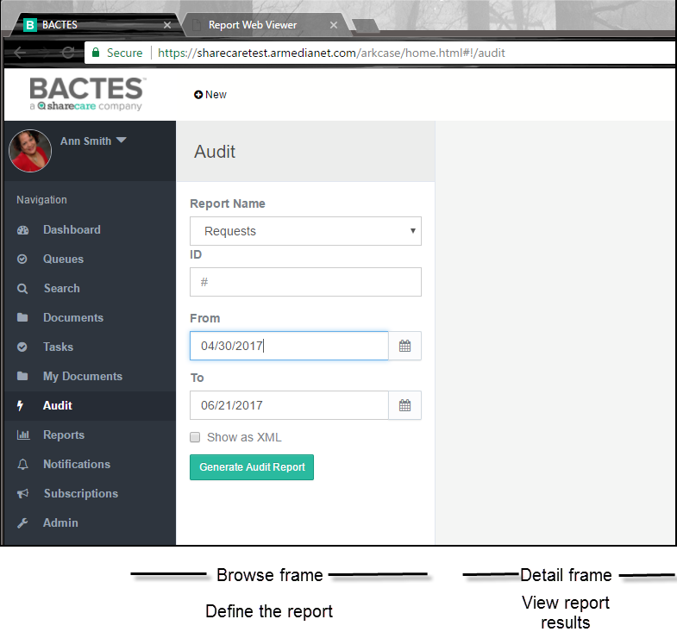
Audit content can be based on type of information (Object Type), such as requests or files, or on All.
A note about All audit reporting
It is wise to use All with discretion, particularly with a blank ID field or for a wide time span. Audit results are comprehensive, including business-level activity as well as records of behind-the-scenes system events. As the repository grows, the required time and amount of results of too-broad criteria may have minimal advantage.
An entry in the ID field will audit a specific request: actions on the request or one of its files. You can define a date range for the audit—activity today or for a wider time span.

Define the Audit
Select the audit criteria in the Browse frame. The criteria tailor results, and conserve search time and the amount of the physical data returned.
- To open the module, click the Audit tab in the Navigation frame.
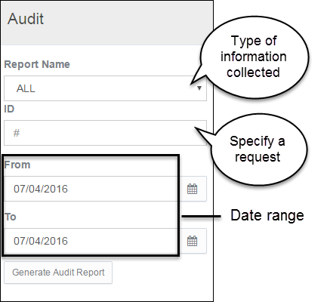
- In the Report Name field, select the type of information to audit.
- Requests
- Files
- All (default)
For example, to audit all activity for today, leave the default All. Add a request number to see all associated request-level and file-level activity.
- Complete the ID field to audit one specific request.
- Use the Date Range fields to confine the results to a period. (The default is today; leaving it as-is returns one day’s results.)
- In the From and To boxes, enter, or select from the calendar, a date range.
- If manually entering dates, follow in the same format as shown in the field: MM/DD/YYYY.
- To select the date for either or both fields, click the date picker icon to open the calendar.
The buttons in the month title panel open the previous |<| month or the next |>|month.
- Click Generate Audit Report to return the audit results.
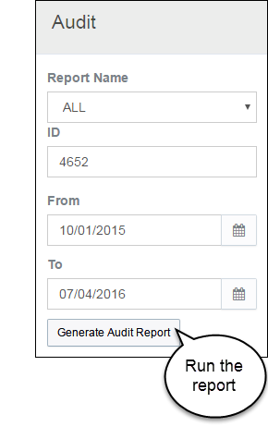
The report displays in the Detail frame of the page.

View Audit Results
The report displays up to 20 entries on a page. Audit results list by date, descending order (newest first).
Request-level Audit
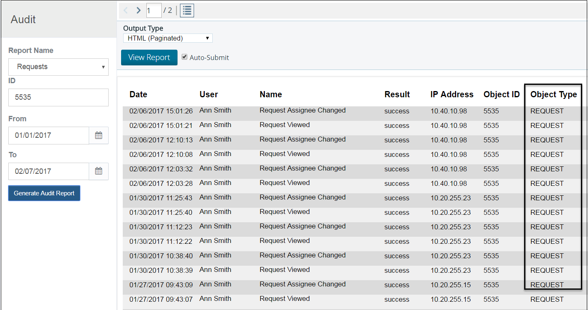
File-level Audit
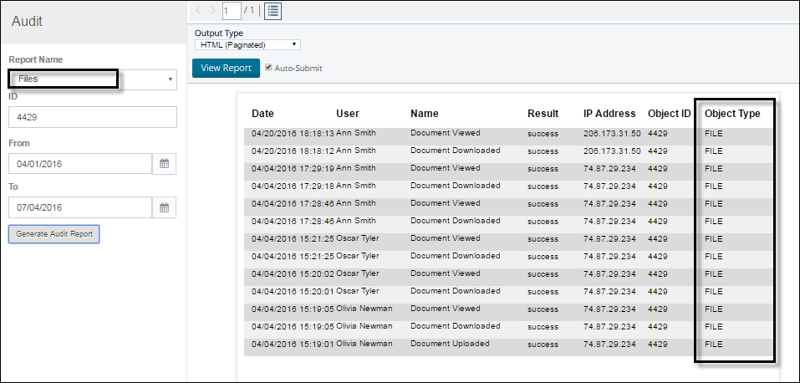
“All” Audit
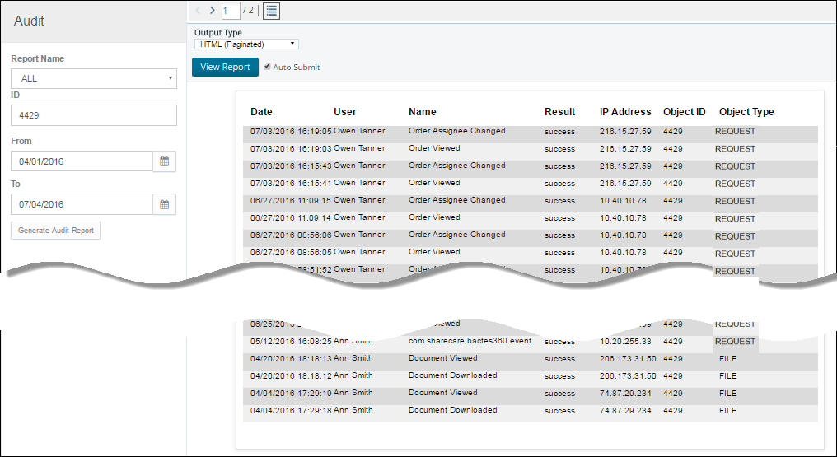
Audit Report Content
Report column
Date | The date and time that the action occurred.
User | The person who initiated the action.
Name | The action that occurred, for example, the item was viewed, changed, or downloaded.
Result | The requested action successfully occurred or it did not.
IP Address | The computer from which the action was taken.
Object ID | The associated request number.
Object Type | Either Request , File or All . If you opt for ALL, Object Type can be Request, Task, File, Widget_List, etc.
Report Actions
By default, the audit results page makes available options for formatting and viewing the content. The group of actions appears in the View Report panel above the results in the upper-left corner of the Detail frame.
- Left and right arrows: click |>| arrow-right to move ahead one page in the results, click |<| arrow-left to go to the previous page.
- Number of pages in the report: shows the page of pages, for example 1 / 5, where you can enter a number in the box and jump to any page of the report.
- Toggle button expands the space for viewing the report. It hides (and redisplays) the View Report panel that appears above the report content.
- Output Type dropdown is a list of options for saving the report. Use the View Report button to see the report in the new file format.

Save the Audit Report
The report results is a fixed display of data that has been collected from the database. As is, its content cannot be manipulated, copied, or printed from the on-screen page.
To create a copy of the report, save it in another format.
- Click in the Output Type field to open the list of available file types.
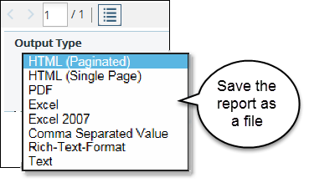
- Click to select a file type. If the new file does not open, click View Report.
- Save or view in the selected file format.

Output Type
The Output Type box is list of options for making the content available for other purposes. The default display is HTML, in paginated form.
Formats | Results
HTML (Single Page) | Shows the onscreen results in a single-page, scrollable format.
PDF | Opens the results as a .pdf file, which you can save.
Excel | Creates a spreadsheet of the report, in which the content can be used like any other Excel file
Comma Separated Value (CSV) | Formats the report in a spreadsheet, suitable for copying to a database or another environment.
Rich-Text Format | Creates a Microsoft Office-compatible (Word) version of the report.
Text | Creates a plain text file for use in generic text editors and utilities.

Administration
Authorized users configure application settings in the Administration module. The module is the central location for customizing and maintaining HDS for ongoing business use.
HDS streamlines administration—not all business-level modifications require technical intervention. Authorized users can easily make changes on the fly (effective immediately).

The Administration module is structured for object-based management control. A visually oriented user interface simplifies the capabilities for managing security, setting access permissions, integrating business process, and conforming business context.
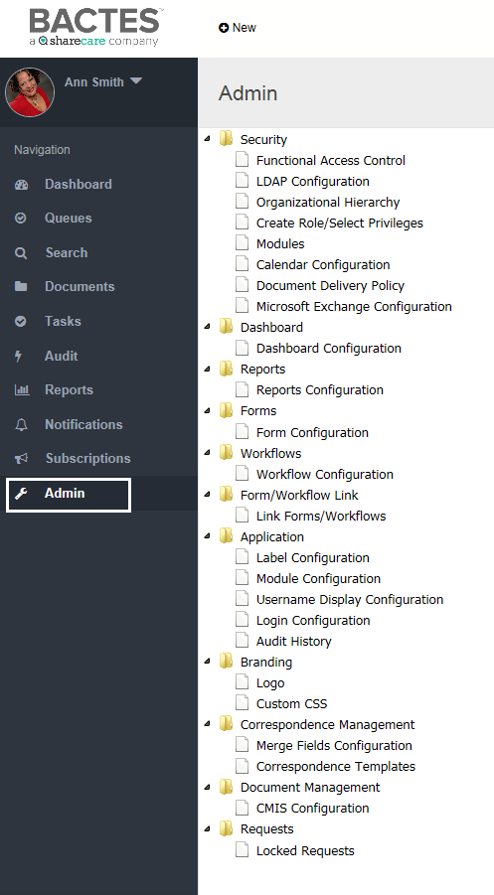
The Admin browse frame lists the application objects that can be configured. Select an object from the tree-view list to open its configuration detail.

Security
Use to configure functional access—associate LDAP and ad hoc groups to each application role. The Lightweight Directory Access Protocol (LDAP) is the group structure used at the organization level (HDS enterprise). HDS access control defers to the LDAP settings. Authorized users can view the LDAP group structure and create and manage ad hoc groups.
Functional Access Control
LDAP Configuration
Organizational Hierarchy
Create Role/ Select Privileges
Modules

Functional Access Control
Purpose: authorize application roles.
- In the Security folder, click Functional Access Control. The existing application roles appear in the Choose Application Role list.
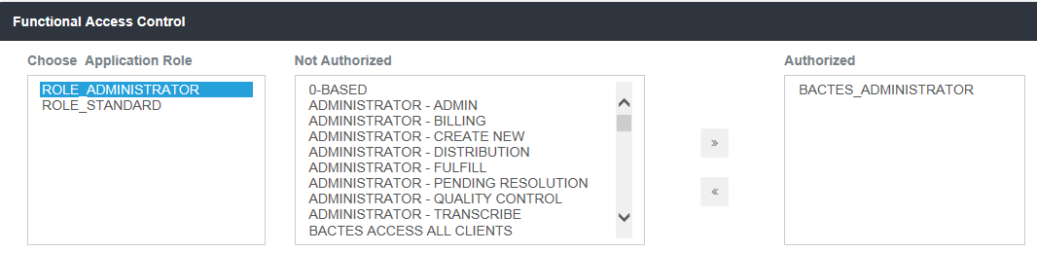
Use the selections to create functional access assignments.
- To enable controls, click a group name from the Not Authorized list and click the right chevrons button to move it to the Authorized list.
- To remove authorization, click the group name from the Authorized list and click the left chevrons to move it to the Not Authorized list.

LDAP Configuration
Purpose: create and maintain LDAP directories integrated in HDS.
The LDAP directory(s), on which HDS group and individual permissions are based, are listed on the page. (See example below.)

Modify an LDAP Configuration
- In the Security folder, click LDAP Configuration.
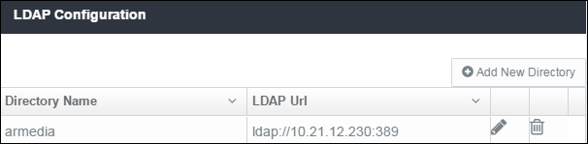
- To modify an existing directory, such as the directory name, LDAP URL and other attributes, click the edit button. The Edit Record window shows the existing attributes in text fields.
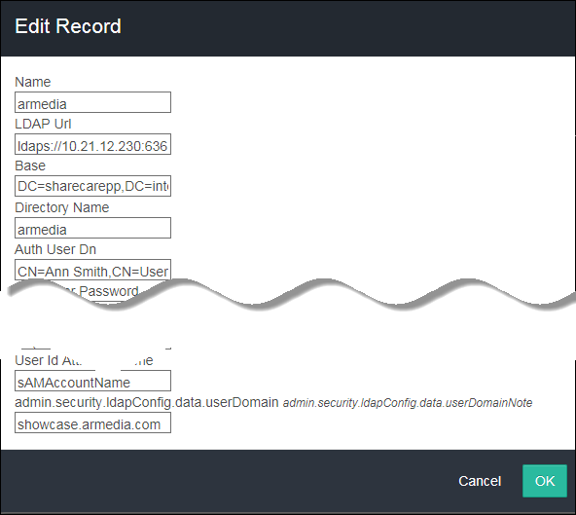
- To save updates, click OK.

Add New LDAP Directory
- Click the Add New Directory button at top-right on the page. A blank record opens, like the example below.
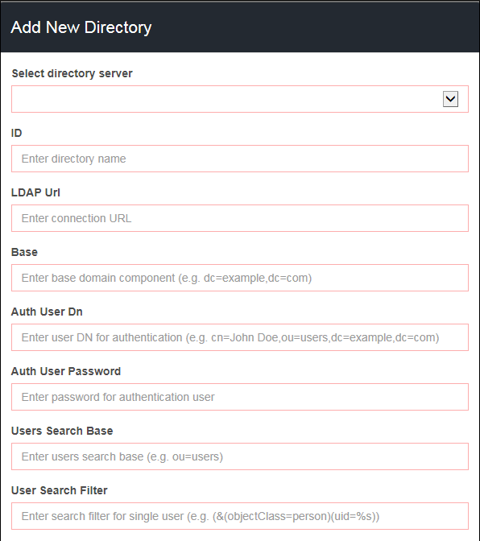
Required fields are marked in red. Click OK to add the directory to the LDAP configuration list. The button is dimmed (not available) until you enter the minimal information.

Organizational Hierarchy
Purpose:
- Store and maintain all HDS-LDAP groups (queue and admin access)
- Create and manage all HDS ad hoc groups (client access)
In the Security folder, click Organizational Hierarchy. The current organizational hierarchy shows the structure for the LDAP and ad hoc groups.

Ad hoc groups
A collection of ad hoc groups appears in the hierarchy list. Actions are available specifically for ad hoc groups.

Managing members
View group members: expand the folder to see the current group membership.
Remove a group member: click the delete icon to remove a member from the group.

Managing groups
Use the set of icons for group-level actions (hover on an icon to view its function).
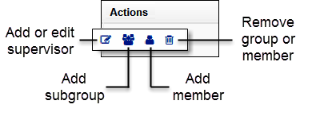
Add people: when adding people, the dialog box opens to search for names.
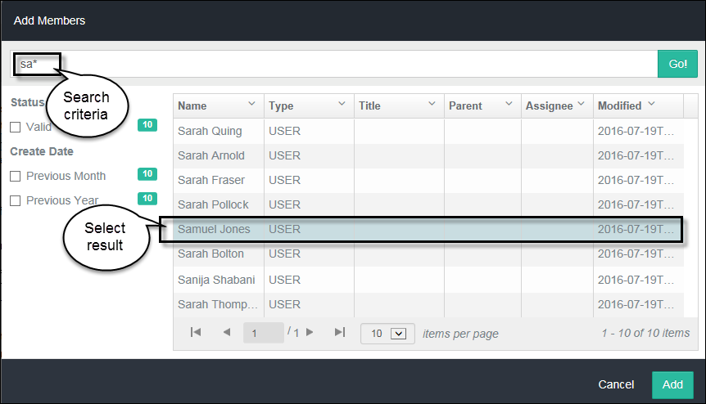
- Type full or partial name and click Enter or Go!. The Add button becomes available only after the results appear.
- Select the name from the results and click Add.
Add groups: a text dialog box opens to create a new ad hoc group or subgroup.
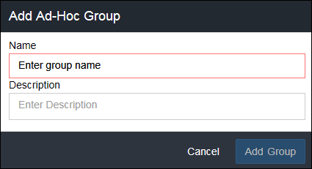
Group name is minimum required information (text box outlined in red). The Add Group button becomes available only after entering text in the Name field.
Note: The system automatically creates an ad hoc group when it receives a new client from CRM.
Remove a group: click the delete icon.

LDAP groups
A collection of LDAP groups appears in the hierarchy list. You can only view the membership lists of the HDS LDAP groups.
View group members: expand the folder to see the current group membership.

Create Role/ Select Privileges
Purpose:
- Assign privileges to user roles
- Create roles and edit role titles
- In the Security folder, click Create Role/ Select Privileges.
Note: The options you see may be different than this example.
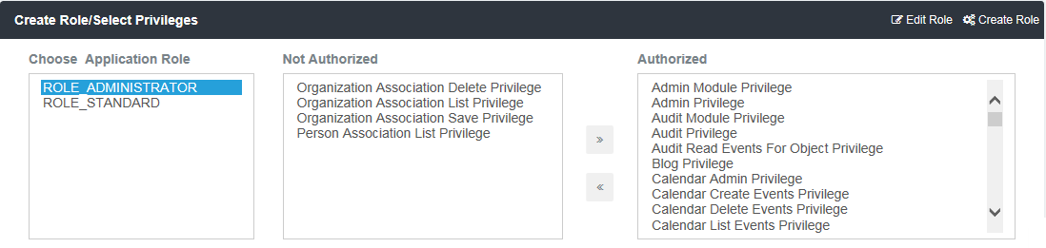
- Select an Application Role from the first list.
- Use the chevron buttons to move privileges between the Not Authorized and Authorized lists.
  - Click the right chevrons button to move a privilege to the Authorized list.
  - Click the left chevrons to move a privilege to the Not Authorized list.

Edit Role
The current role name appears in the text box.
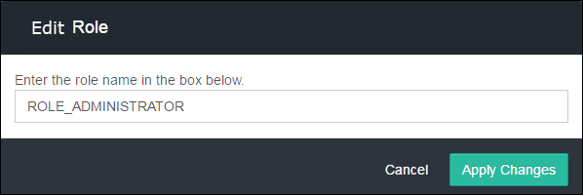
Type in the revision to the name and click Apply Changes.

Create Role
Use the space for creating new roles. Enter the name in the text box.

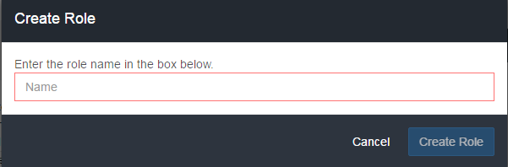
The field is required (framed in red). Click Create Role when the button becomes available. The new role appears in the Application Role list.

Modules
Purpose: Set role permissions for access to each HDS module.
- In the Security folder, click Modules.
Note: The list of modules you see may be different than this example.
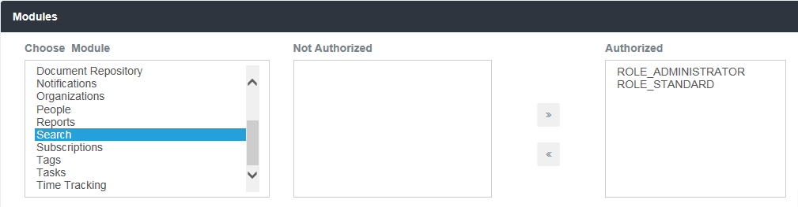
- Select a module from the Choose Module list.
- Use the chevron buttons to move individual roles between the Not Authorized and Authorized lists .
  - Click the right chevrons button to move a role to the Authorized list.
  - Click the left chevrons to move a role to the Not Authorized list.

Dashboard Configuration
Purpose: Use to assign access authorization to module objects.
- In the Admin explorer frame, open the Dashboard folder and click Dashboard Configuration.
Note: The configuration screen you see may be different than this example.
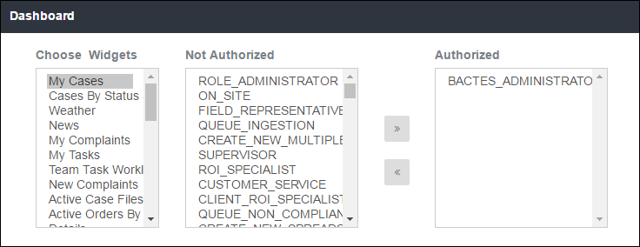
- Click a widget from the Choose Widgets list.
- Use the chevron buttons to move individual roles between the Not Authorized and Authorized lists.
- Click the right chevrons button to move a role to the Authorized list.
- Click the left chevrons to move a role to the Not Authorized list.

Reports Configuration
Purpose: Authorize access to Reports.
- In the Admin explorer frame, open the Reports folder and click Reports Configuration.
Note: The configuration screen you see may be different than this example.
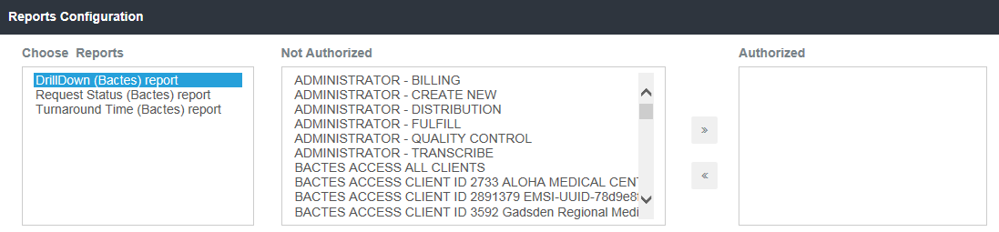
The report name will be highlighted.
- Use the chevron buttons to move individual roles between the Not Authorized and Authorized lists.
  - Click the right chevrons button to move a role to the Authorized list.
  - Click the left chevrons to move a role to the Not Authorized list.

Workflow Configuration
Purpose: Use to manage Queue process workflows. The page shows a list of existing workflows.
- In the Admin explorer frame, click Workflow Configuration.
Note: Not all of the workflows in the example may be relevant to the current HDS environment.
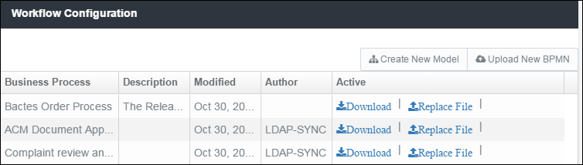
Workflow status
Business Process | Name of the workflow
Description | If included, describes the workflow.
Modified | The date of the most current version.
Active | Download a new workflow file for review.  Replace File and create a new version.  Version History of the workflow, provides the option to reinstate a previous version.
Create New Model | N/A
Upload New BPMN | Add a new Business Process Model and Notation (new workflow).

Application Configurations

Label Configuration
Purpose: Use Label Configuration to customize the user interface.
- In the Admin explorer frame, open the Application folder and click Label Configuration.
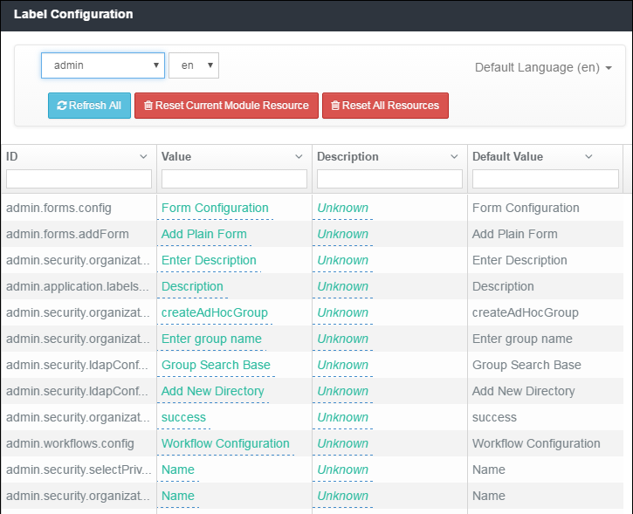
Each module (HDS modules and integrated application modules) has a list of pre-defined labels. Labels are associated to fields, messages, buttons, table titles, table columns, form names, and more.
Module list box | Click in the top-left field (default is admin) to view the list of modules.  Select a module from the list, for example, Audit, Reports, and Queues, or request-info, document-details, and upload-new-request to see its labeled objects.
Language | Pre-set to en (English-U.S.).
ID | System-defined object. These are not modified.  To filter the list or find a specific ID, type a partial or full ID name in the column heading text field.
Value | The title (label) for the object. You can customize the values for any of the labels. The initial value matches the system default value listed in the Default Value column.  To filter the list or find a specific value, type a partial or full name entry in the column heading text field.
Description | You can add a description for each label.  To filter the list or find a specific value, type a partial or full name entry in the column heading text field.
Default Value | System-defined value, does not change.  To filter the list or find a specific value, type a partial or full name entry in the column heading text field.

Column list | Click the disclosure button in a column heading to reorder or hide the list  - Ascending order  - Descending order  - Hide column

Changing labels
- To change a Value or Description, click the current value to open a pop-up box.
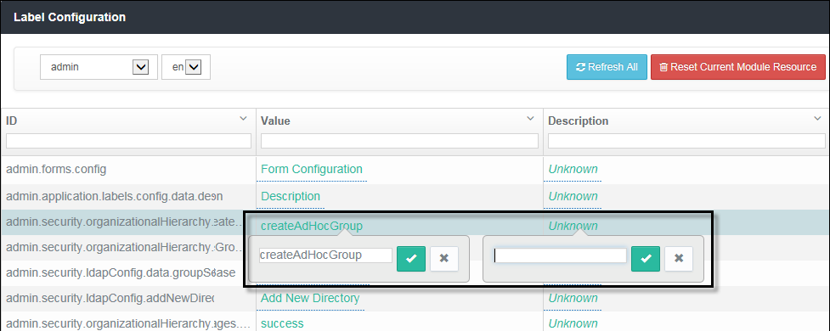
- Type in the new value.
- Click the check mark to save the change and close the pop-up box.
Click the X button to cancel the change and close the box.

Module Configuration
Purpose: Use Module Configuration to enable the objects within the modules.
- In the Admin explorer frame, open the Application folder and click Module Configuration.
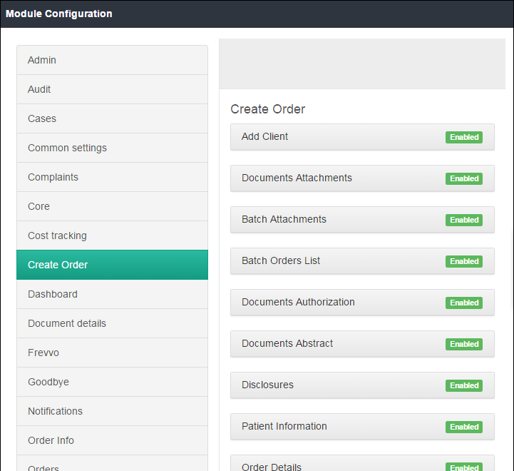
The page shows the list of modules in the left frame.
- Click a module to see its configurable objects.
- To change the status of an object, click the button to toggle between Enabled and Disabled.

Branding
Purpose: Maintain global elements that customize the site.
- In the Admin explorer frame, open the Branding folder and click Logo or Custom CSS.

Logo
Purpose: Store the logo(s) that will display in HDS.
The logos will appear in the Header title and the Login title.
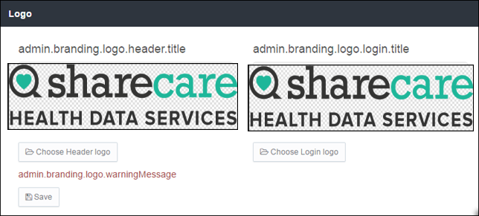
- Click Choose to add or replace a logo.
- Click Save to update the logo.

Custom CSS
Purpose: Maintain the colors that appear on the pages.
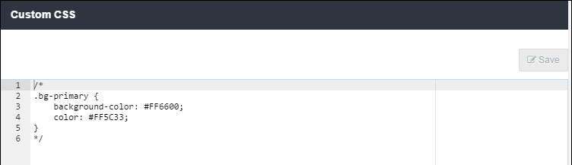
- To modify, change the CSS code and Save.

Correspondence Templates
----Future Release----
Purpose: Add and maintain the collection of correspondence templates.
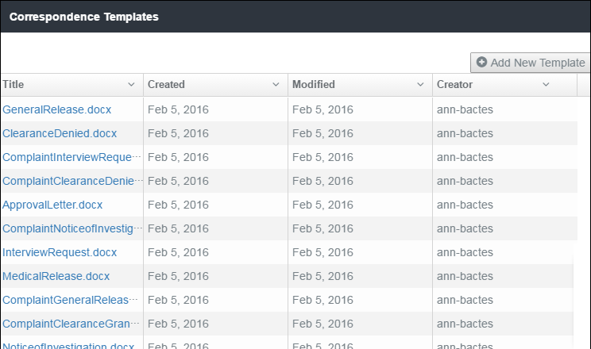
Modifying a template
To modify an existing template, click the file name in the Title column. The Do you want to save or open dialog box opens at the bottom of the screen. Select open or a save option to proceed.
With the template (document) opens, make changes and save the file. If you did not save the file before editing, Windows Explorer opens. Choose the save location.
Replacing a template
Click + Add New Template on the Correspondence Templates title bar to open Windows Explorer. Browse your folders and select the document, then click Open. The document (of the same name) replaces the previous version.
Adding a template
Click + Add New Template on the Correspondence Templates title bar. Windows Explorer opens.
Browse and select the document from your share drive.
Click Open.

Locked Requests
Purpose: Administrators can unlock requests.
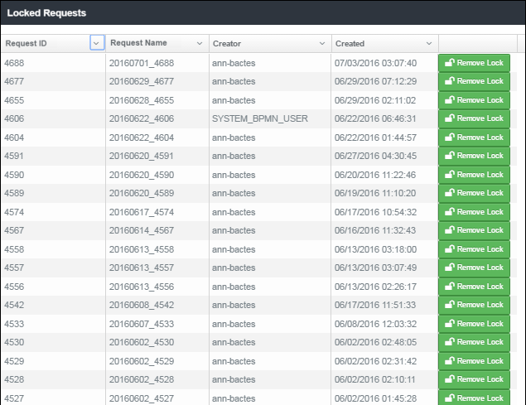
All locked requests appear on the list. The Remove Lock button changes the lock status.

